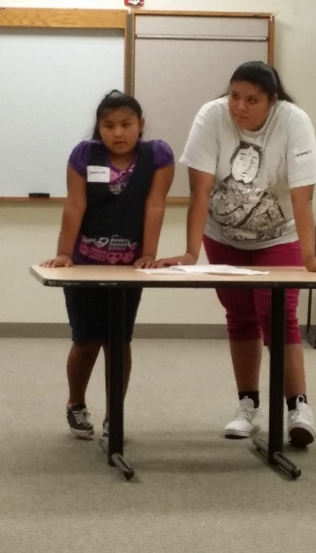
Summer 2013
Free summer activities that combine the importance of community knowledge and storytelling, interactive science learning and career opportunities in science, technology, engineering and math (STEM).

Activity 1: Funds of Knowledge
We may not think of it, but from the very moment we are born our families are sharing traditions, stories and ways of doing things. We don’t always recognize how this knowledge is important of who we are and how we each see the world. In this activity, we participated in a game and art activity to uncover our secret ways of knowing.
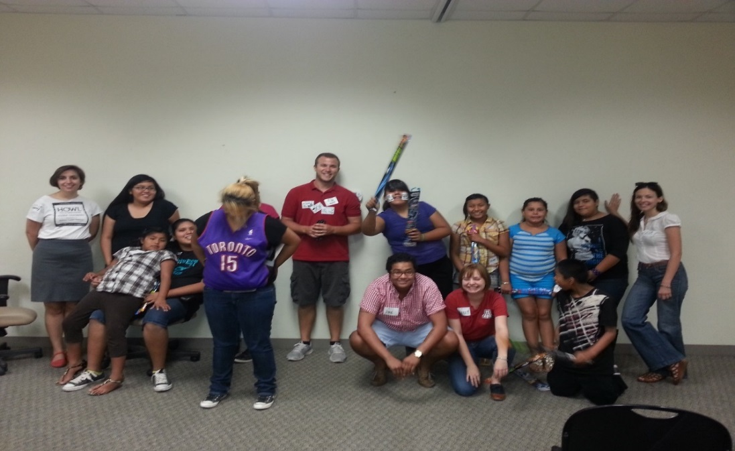
Activity 2: Career Planning for Students
Participants learned about what nontraditional careers are; the barriers that may exist for nontraditional students as well as the benefits of choosing a non-traditional career, including careers in science, math and technology. The session concluded with a hands-on experiment related to several nontraditional careers. The workshop was intended for students, parents and educators.
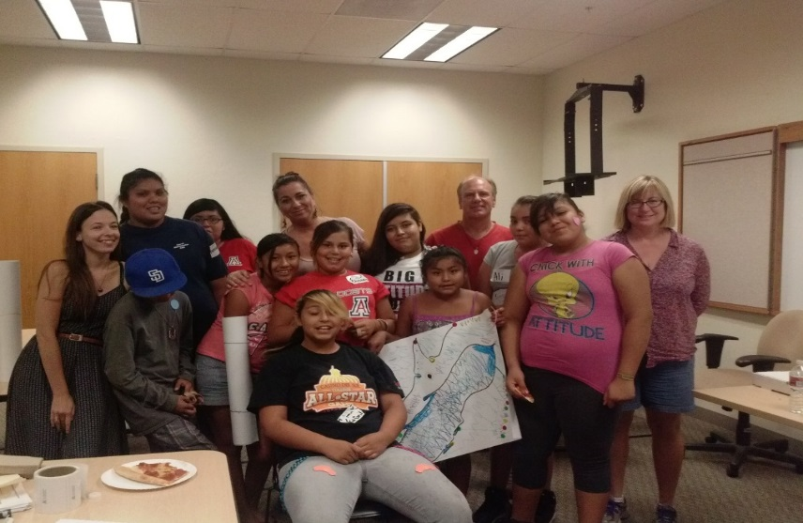
Activity 3: Explore the Gulf of California and NW Mexico!
We explored the Gulf of California, Mexico with naturalist, Tad Pfister, who has worked and lived in the region for over 25 years. We learned about the natural history of what some people say is the aquarium of the world, the Gulf of California or the Sea of Cortez. We participated in a presentation about whales, dolphins and other wonders of the sea, as well as about the native peoples of the region, the Seri or Com Caac—and we even created our own special maps of this amazing place!

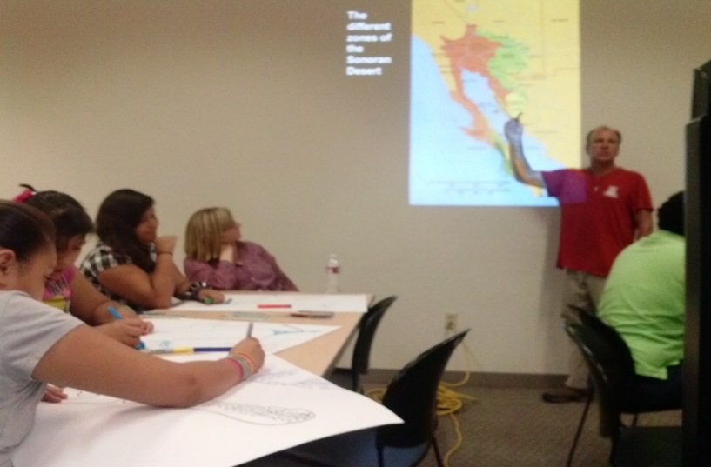
Activity 4: Water Science & Swimming
We learned why people and things float when placed in the water. We explored the concept of buoyancy and reviewed the year’s previous physics concepts of inertia and Newton’s laws of motion, all combined with end of the summer swimming party fun at the Pascua Yaqui Wellness Center.

Summer 2014
Activity 1: Digital Storytelling I
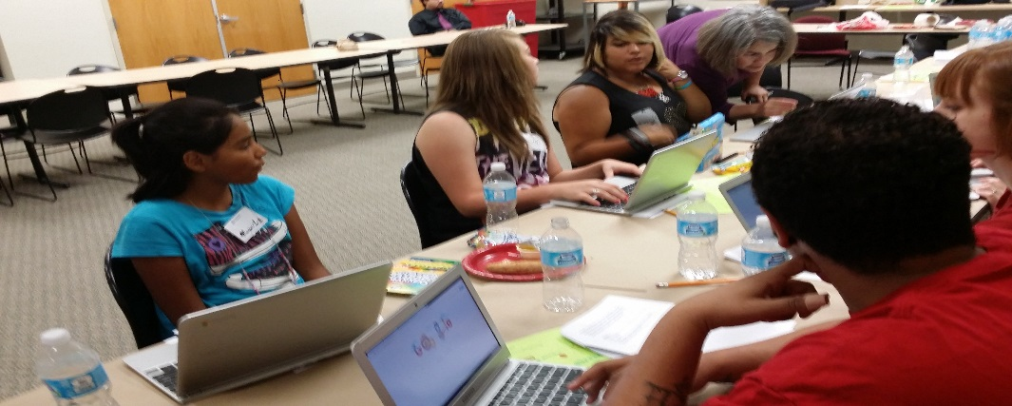
This was an in-depth activity which spanned over a two sessions. The first session entailed researching one’s self through family and gathered photos, names and important places for the youth to develop their own story called, My Multicultural Self. Each student utilized a laptop to create their digital story.

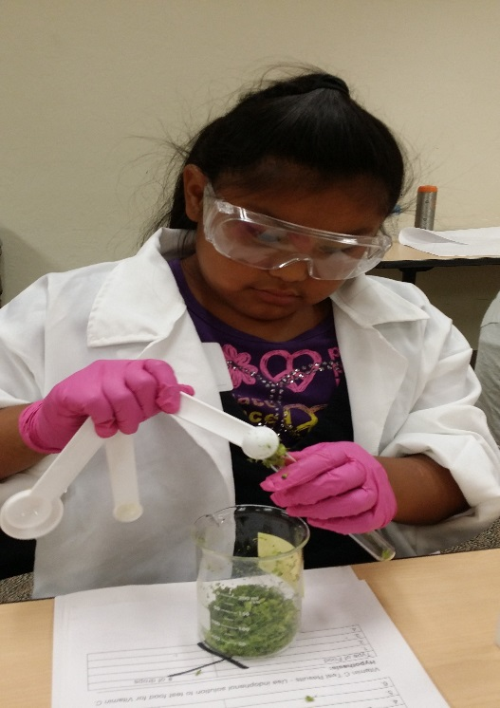
Activity 2: Digital Storytelling II
The second half of digital storytelling involved the mentees developing a digital picture album from the photos they had gathered and then created their story in digital forms with words, photos, and even animation. The mentees were pleased to share their digital stories with the group.

Activity 3: Food Detectives
In this hands-on workshop, we explored the chemistry, culture and geography of food and access to food. Together we will use the chemistry to test food for certain nutrients, participate in a fun role-playing game related to food access and use mapping and map-making to identify and document access to affordable and healthy food for neighborhoods and communities.
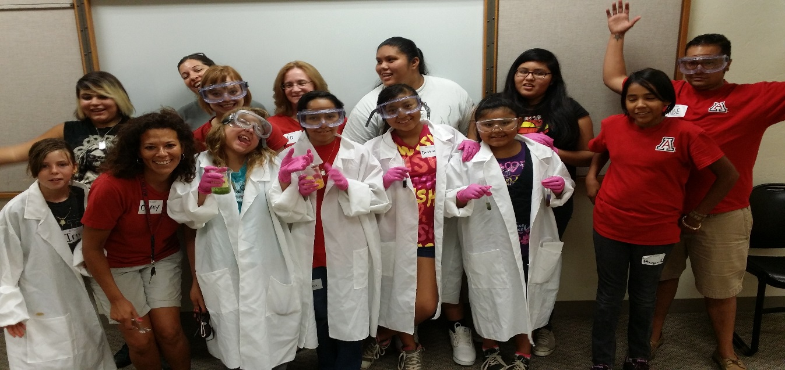
iSTEM Food Detectives

Summer 2015
Activity 1: Make A Friendship Bracelet

Activity 2: SOMA Cube

