Optical Science
Arizona Science Standards

3rd-5th grade

1.1PO 1, 1.1.PO 2: Observe, ask questions, and make predictions

1.2.PO 1, 1.2.PO 2,1.2.PO3, , 1.2.PO 5: Participate in planning and conducting investigations, and recording data.

1.3. PO 4: Organize and analyze data; compare to predictions

1.4.PO 1, 1.4.PO 3: Communicate results of investigations.

5.3.PO1: Investigate different forms of energy. Demonstrate that light can be reflected, refracted and absorbed. (3rd grade)

6th-8th grade

1.1.PO 1: Formulate predictions, questions, or hypotheses based on observations. Locate appropriate resources.

1.2.PO3, 1.2.PO 4. 1.2.PO 5: Design and conduct controlled investigations.

1.3.PO 3, 1.3.PO 5: Analyze and interpret data to explain correlations and results: formulate new questions.

1.4. PO 5: Communicate results and conclusion of the investigation

2.1.PO1: Identify how diverse people and/or cultures, past and present, have made important contributions to scientific innovations

Introductory Material: Optical Science: The Science of Light

- Overview: An introduction to Optical Science
- A Native American Story about light (Gallinomero Tribe)

Activity 1: Prisms and Natural Light

Activity 2: Prisms, Flashlight & Other Artificial Light Sources

Activity 3: Make a Permanent Rainbow

Activity 4: Spectroscope/Gradient Glasses

Activity 5: Make a Green Gumball Black

Field Trip: University of Arizona Flandrau Science Center

Overview: An Introduction to Optical Science

Here is how an optical scientist might explain how rainbows are formed:

White light is composed of all the visible colors in the color spectrum, a fact that can be easily proven through the use of a prism. As light passes through a prism, it is bent, or refracted, by the angles and plane faces of the prism and each wavelength of light is refracted by a slightly different amount.

Violet has the highest frequency and is refracted the most. Red has the lowest frequency and is refracted the least. Because each color is refracted differently, each bends at a different angle, resulting in a fanning out and separation of white light into the colors of the spectrum. Water droplets in the air can act in a manner similar to that of a prism, separating the colors of sunlight to produce a spectrum known as a rainbow.
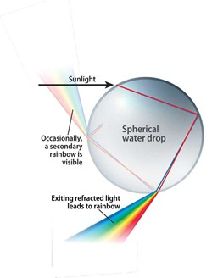
To be able to see a rainbow, you must be standing with the sun behind you.

The sunlight shines into the water droplets in the air, bending as it moves from the air into the water, reflecting off the sides the drops, and bending again as it exits the drops. As a result, all of the colors in the white light of the sun separate into the individual bands of color that are characteristic of a rainbow.

A Native American Story about Light
(Gallinomero Tribe)

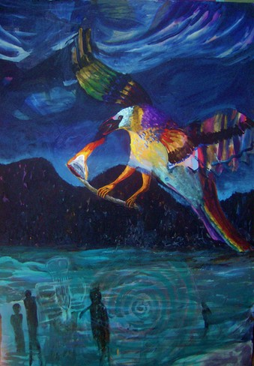
Excerpt from a book written by James Alexander Throm called: The Red Heart.

“The Rainbow Crow was beautiful to hear and to see, back in the days when it never got cold, back in the Ancient Days, before Snow Spirit appeared in the World. When the Snow Spirit did appear, all the people and animals were freezing and a messenger was selected to go up to
kijilamuh ka’ong, The Creator Who Creates By Thinking What Will Be.

The messenger was to ask The Creator to think of the World as being warm again so that they would not all freeze to death. Rainbow Crow was chosen to go and he flew upward for three days. He got the Creator’s attention by singing beautifully, but even though he begged the Creator to make it warm again, the Creator said He could not, because He had thought of Cold and He could not unthink it. But He did think of Fire, a thing that could warm the creatures even when it was cold. And so He poked a stick into the Sun until it was burning, and then gave it to Rainbow Crow to carry back to earth for the creatures. The Creator told Rainbow Crow to hurry before it burned all up.

Rainbow Crow dove down and flew as fast as he could go. The burning stick charred all of his beautiful feathers until they were black and since he was carrying the stick in his beak, he breathed the smoke and heat until his voice was hoarse.

And so the Rainbow Crow was black and had an unpleasant cawing voice forever after, but all the creatures honored him, for he had brought Tindeh, fire, for everyone to use.

The Crow is to this day, still honored by hunters and animals, who never kill it for food…and, if you look closely at the Crow’s black feathers you can still see many colors gleaming in the black.”
Activity 1: Prisms & Natural Light

What You Will Need:

- Scissors
- Cardboard
- Prism
- White paper
- A flash light
- Your Science Journal
- Colored pencils, crayons or markers

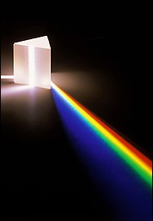

Directions:
- Cut a slit in a large piece of cardboard.
- Place the cardboard in a sunny window so that a shaft of sunlight shines through the slit.
- In one hand, hold a prism in front of the cardboard so that the sunlight passes through it.
- With your other hand, hold a sheet of white paper so that the light passing through the prism shines on it.
- You will see a rainbow of colors on the paper.
- In your journal, make a sketch of what you see and label the colors of the spectrum.
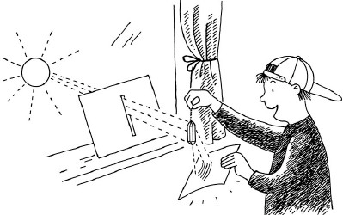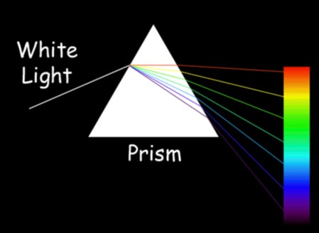

Activity 2: Prisms, Flashlight & Other Artificial Light Sources

What You Will Need:
- A prism
- A flashlight
- Different sources of light

Directions:
- Place the prism on a flat surface with plenty of space.
- Shine the flashlight on the prism in a manner that allows the light to pass through the prism from one side to the other, rotating the prism until it produces the spectrum.
- Observe the colors and write down your observations.
- Experiment with other light sources, fluorescent lights, computer screens, and light bulbs.

Question: How are the rainbows different depending on the light source?

(cont. on next page)

JOURNAL IT!
Sketch out the different spectrums (rainbows) you create, make sure to write down the kind of light you used to create each spectrum.

What’s Happening Here?
White light is composed of all the rainbow colors, A prism can be used to break up light to its equivalent spectral colors, which include the colors red, orange, yellow, green, blue, indigo and violet.

Activity 3: Make a Permanent Rainbow
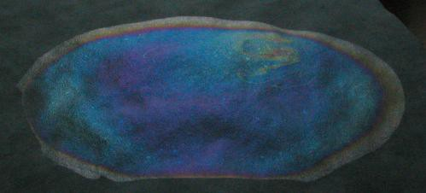
You have probably seen the beautiful rainbow colors caused by a tiny bit of oil floating in a puddle of water. In this project, we are going to capture those colorful patterns on paper, in a permanent form, so you can view them anytime you like, without a messy puddle.

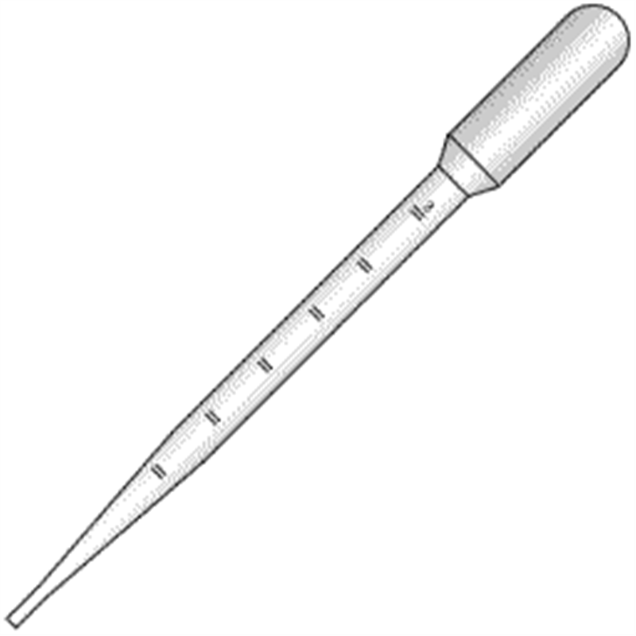
What You Will Need:
- A piece of black construction paper
- A pan or similar container that can hold water
- Clear fingernail polish
- An eye dropper or a pipette. Cut a slit in a large piece of cardboard

(cont. on next page)

Directions:

- Fill the pan with water to cover the paper with at least a half of an inch of water.
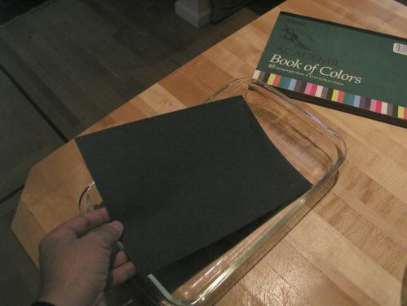

- Put the eyedropper into the nail polish bottle, and squeeze just a little air out of it, to get just a half of an inch or so of nail polish into the eyedropper. We only need a single drop.
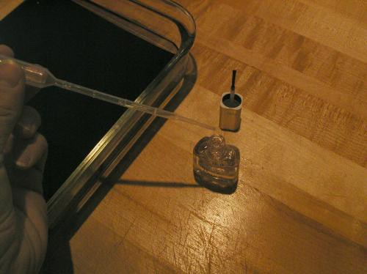

- Drop a single drop of nail polish onto the surface of the water.

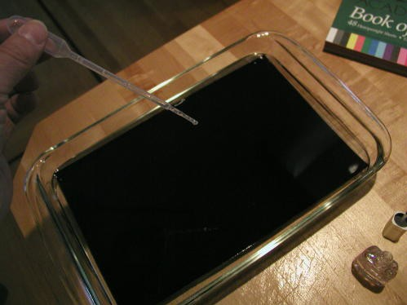

- The nail polish drop will quickly expand to make a circle of film on the water. This film will be so thin, that it will only be as thick as one wavelength of light.
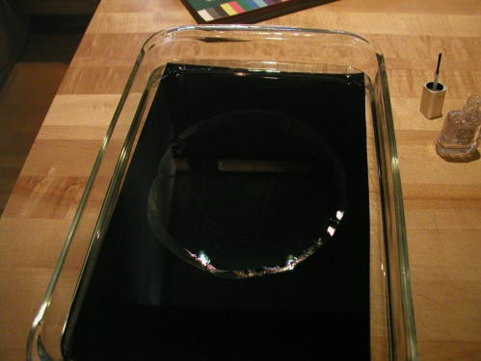

- Let the circle of nail polish film dry for a few minutes. The edges will generally wrinkle a bit, and the center will take longer to dry than the edges.
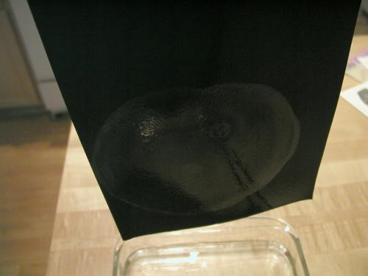

- Gently lift one end of the paper out of the water, making sure you catch the edge of the thin circle onto the paper.
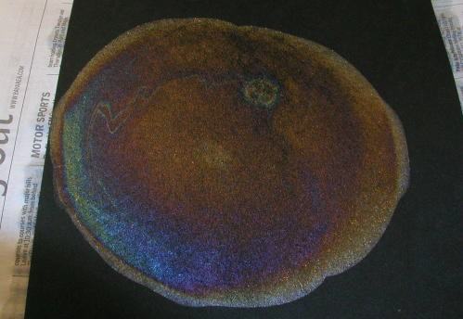

- Let the water drip off the paper into the pan, and then set the paper onto some newspaper to dry.

- To view the colors, hold the paper flat towards the light, and view it at a low angle.

(cont. on next page)

JOURNAL IT!
- Where and when do you see rainbows in real life?
- What are some stories you have heard about rainbows?

What’s Happening Here?

The colors are caused by the interactions of several interesting qualities of light. Light travels at different speeds in different materials. In air it travels very fast (about 299,792,458 meters per second). In water, light travels slower than it does in air. In the film we made from the drop of nail polish, the light is even slower, because light even slower in dried nail polish. Light travels in waves. We can picture the waves of light as looking like waves of water in the ocean.

Activity 4: Spectroscope/Gradient Glasses
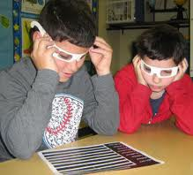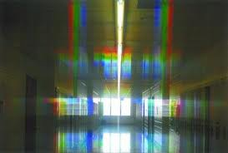

What You Will Need:
- Diffraction Gradient Glasses
- Incandescent light bulb (in a lamp—can you find one?)
- Flashlight
- String of clear holiday lights (Facilitator should plug in a strand of holiday lights for use with this experiment)
- Fluorescent light bulbs (in your school)

Separating White Light Into Colors
- Set up a few different kinds of white light sources in a room. The best rainbows come from the smallest points of light; for example, a single holiday light or a small, bright flashlight.
- Look at the different light sources with the glasses on and notice what the rainbows look like.
- Turn the light source off and on, what do you see?

(cont. on next page)

JOURNAL IT!

- Are the colors always arranged in the same order (red, orange, yellow, green, blue, indigo, and violet)?
- Is the same color always closest to the light source?
- Draw your own pictures of the rainbows you saw in the prism glasses.
- Where do you think the colors in the rainbows come from?

What’s Happening Here?
These colors were already there, hidden in the white light, and the glasses separated them out into their individual colors. Raindrops work the same way, separating sunlight into the colors we see in rainbows in the sky. These colors are actually contained in sunlight all the time, but we cannot see them because they are usually mixed together into white.

These glasses contain a series of very narrow lines called a diffraction grating. When light passes through a series of tiny slits or grooves called a diffraction grating, white light is spread out into a spectrum according to wavelengths of the light source.

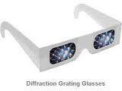
Gradient Glasses: Take them home!

Besides looking cool, use your gradient diffraction glasses explore the spectra effects of different lights sources.

(cont. on next page)

Put your Gradient Glasses on & Check out your:
- TV
- Computer Monitor
- Different Lights in your house (incandescent light bulb, a fluorescent bulb, a black light, and others)
- Flashing lights
- Street lights
- Car lights
- Neon lights
- A flashlight

Warning: Don’t ever look directly at the sun!!! It can cause serious damage to your eyes.

Compare the spectra of various sources. When you view different light sources, look for specific colors and notice the spacing between colored lines. The heated tungsten filament of an incandescent light bulb produces a continuous spectrum, and one color shades into another. The electrically excited mercury vapor in a fluorescent bulb produces distinct colored lines; the phosphors that coat the inside of the bulb produce a continuous spectrum.

Some other suggested light sources are a candle flame, a camping lantern, yellow streetlights (sodium produces the color), blue streetlights (mercury vapor produces the color), neon signs, and slide projector lamps.

Activity 5: Make a Green Gumball Black

What You Will Need:
- A shoebox
- A ruler
- Scissors
- Several gumballs of different colors (white, red, blue, green, etc.)
- Tape
- A strong light source (or a sunny day!)
- Cellophane of several colors

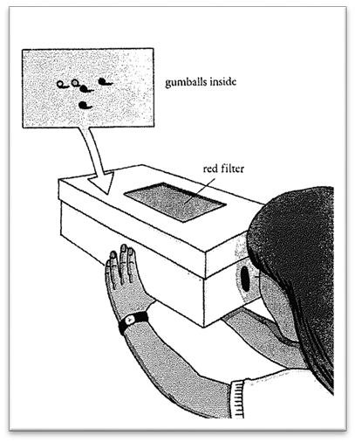
Directions:
  - Cut a rectangular hole in the top of the shoe box 3 inches wide by 6 inches long.
  - Cut out a rectangular piece of red cellophane about 8 inches wide by 14 inches long.
  - Fold it in half twice to produce a filter of four layers with a size of about 4 inches by 7 inches.
  - Tape the red cellophane filter to the inside of the shoebox top so that it completely covers the rectangular hole.
  - Cut a 1-inch round hole in one end of the shoebox.
  - Put the gumballs inside the shoebox and put on the cover.
  - Go out into the sunshine or shine a lamp through the cellophane.
  - Look into the box through the round hole.
  - See what colors the gumballs are.
  - Repeat this experiment with different colors of cellophane.
  - Describe your findings in your Science Journal.

Optics Field Trip: The University of Arizona Flandrau Science Center
http://flandrau.org/

Contact:
Dr. Srin Manne, UA Physics
smanne@physics.arizona.edu ; outreach-group@physics.arizona.edu
(520) 626-5305

Sponsored by College of Science departments and led by UA undergraduate students, give participants the opportunity to experience hands-on, inquiry-based activities in a variety of science disciplines. Our visit was tailored to our specific needs in focusing on physics and especially optics-related activities.

