Flight and Motion
Arizona Science Standards

3rd-5th grade

1.1PO 1, 1.1.PO 2: Observe, ask questions, and make predictions

1.2.PO 1-3, 1.2.PO 5: Participate in planning and conducting investigations, and recording data.

1.3. PO 4: Organize and analyze data; compare to predictions

1.4.PO 1, 1.4.PO 3: Communicate results of investigations.

5.2.PO1-4: Understand the relationship between force and motion.(5th grade)

5.3.PO1: Investigate different forms of energy. Demonstrate that light can be reflected, refracted and absorbed. (3rd grade)

6th-8th grade

1.1.PO 1: Formulate predictions, questions, or hypotheses based on observations. Locate appropriate resources.

1.2.PO3-5: Design and conduct controlled investigations.

1.3.PO 3, 1.3.PO 5: Analyze and interpret data to explain correlations and results: formulate new questions.

1.4. PO 5: Communicate results and conclusion of the investigation

2.1.PO1: Identify how diverse people and/or cultures, past and present, have made important contributions to scientific innovations

5.2.PO1-4: Understand the relationship between force and motion (Newton’s 1st & 2nd Laws of Motion). (8th grade)

Introductory Material: The Science of Flight and Motion

- Overview: An Introduction to Flight and Motion
- A Native American Story: How Bat and Flying Squirrel Got Their Wings (Cherokee Nation)
- What do you think? Newton’s Laws of Motion & Laws of Motion related to flight: The Four Forces of Flight
- Fun Facts

Activity 1: Newton’s First Law of Motion: Inertia

Activity 2: The Forces of Flight: Drag

Activity 3: Paper Helicopters
Part I: Thinking about Weight and
Gravity
Part II: Become a Paper Helicopter
Engineer
Activity 4: Make and Race Your Own Balloon
Rocket
Activity 5: Buoyancy Orange Experiment

Activity 6: Surface Tension: Pepper on the Run!

Field Trip: Pima Air and Space Museum

Motion and Flight
People have always understood that flight was possible from observing birds, but it took thousands of years for humans to actually figure out how to take flight. In order for humans to understand how to construct flying machines, and to understand how the moon stayed in the sky and moved around the earth, we needed to understand motion, gravity, force and other scientific ideas. The study of these concepts is a part of a field of science called, Physics. In this unit we will focus on flight and motion, but there are many, many other areas in Physics to explore.

Motion makes the world go 'round and the moon and… In fact, motion makes lots of things go. When we think of motion we often think of cars, bicycles, kids running, basketballs bouncing and airplanes flying. Motion is the changing of position or location.

Careers/Jobs Related to Motion and Flight
- Air Traffic Controller  - Astrophysicist  - Automobile Manufacturer  - Design Engineer  - Electronics Engineer  - Mathematician  - Automotive Engineer  - Astronaut  - Structures Engineer  - Aircraft Mechanic | - Mathematics and Physics Teacher  - Physicist  - Materials Engineer  - Research Assistant  - Astronomer  - Satellite Missions Analyst  - Aerospace Engineer  - Test Engineer

Work and Research Areas

Engineering: Designing and constructing aircraft, and the science of aircraft, spacecraft, automobiles and other vehicles

Aerospace Jobs: Astronauts, pilots, air traffic control specialists, technicians, researchers, engineers

Government jobs: NASA (National Aeronautics and Space Administration), NHTSA (National Highway Traffic Safety Administration), DOT (Department of Transportation), Military

Education in Arizona after High School

Associate Degree (2 years after high school): Aviation Technology, Pima Community College

Bachelor’s Degree (4-5 years after high school): Engineering (Aerospace, Industrial Mechanical and Materials Science), University of Arizona, Arizona State University in Phoenix and Embry-Riddle Aeronautical University in Prescott. Embry-Riddle also offers Aeronautical Science, Aeronautics, Air Traffic Management, Applied Meteorology, Aviation Environmental Science and Space Physics

Master of Science (6-7 years after high school): Engineering: Aerospace, Industrial Mechanical and Materials Science), University of Arizona and Arizona State University

Ph.D. (Doctor of Philosophy)(8-10 years after high school): Engineering (Engineering specializations in Aerospace, Mechanical Engineering and Materials Science), University of Arizona

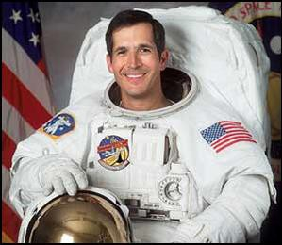
Cmdr. John Herrington - Astronaut, Chickasaw Nation
First enrolled tribal member to fly in outer space, 2002

“American Indians were very careful scientists. They learned important facts about objects in the sky and used them to tell time, to predict the changes of the seasons, and to use maps. Today, American Indian scientists help us learn more about the sky and galaxy. In fact, Native Americans have known for thousands of years that there was a black hole located through the center of the bowl in the big dipper. NASA discovered it just a few years ago.”
– Cmdr. John Herrington, Chickasaw Nation

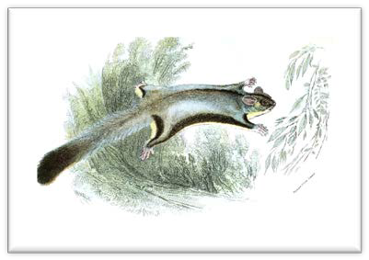
How Bat & Flying Squirrel Got Their Wings
A Cherokee Nation legend

Long ago, the animals sent a message to the birds. "Let us have a big ball game. We will defeat you in a big ball game."

The birds answered, "We will meet you. We will defeat you in a big ball game."

So the plans were made. The day was set. At a certain place, all the animals gathered, ready to throw the ball to the birds in the trees.

On the side of the animals were the bear, the deer, and the turtle. The bear was heavier than the other animals. He was heavier than all the birds put together. The deer could run faster than the other animals could.

The turtle had a very thick shell. So the animals felt sure that they would win the game. The birds, too, felt sure that they would win.
On their side were the eagle, the hawk, and the great raven. All three could fly swiftly. All three had far seeing eyes. All three were strong and had sharp beaks that could tear.

In the treetops the birds smoothed their feathers. Then they watched every movement of the animals on the ground below them. As they watched, two small creatures climbed up the tree toward the leader of the birds.

These two creatures were but a little bigger than mice. "Will you let us join in the game?" they asked the leader of the birds. The leader looked at them for a moment. He saw that they had four feet. "Why don't you join the animals?" he asked them. "Because you have four feet, you really belong on their side." "We asked to play the game on their side," the tiny creatures answered. "But they laughed at us because we are so small. They do not want us."

The leader of the birds felt sorry for them. So did the eagle, the hawk, and the other birds. "But how can they join us when they have no wings?" the birds asked each other.

"Let us make wings for the little fellows," one of the birds suggested.

(Continued on next page)

(How Bat & Flying Squirrel Got Their Wings, continued)

"We can make wings from the head of the drum," another bird suggested.

The drum had been used in the dance the night before. Its head was the skin of a groundhog. The birds cut two pieces of leather from it, shaped them like wings, and fastened them to the legs of one of the little fellows.

Thus they made the first bat.

The leader gave directions. He said to the bat, "When I toss the ball, you catch it. Don't let it touch the ground." The bat caught it. He dodged and circled. He zigzagged very quickly. He kept the ball always in motion, never letting it touch the ground. The birds were glad they had made wings for him.

"What shall we do with the other little fellow?" asked the leader of the birds. "We have used up all our leather in making the wings for the bat." The birds thought and thought.

At last one of them had an idea. "Let us make wings for him by stretching his skin," suggested the eagle. So eagle and hawk, two of the biggest birds, seized the little fellow.

With their strong bills they tugged and pulled at his fur. In a few minutes they stretched the skin between his front feet and his hind feet. His own fur made wings.

Thus they made the first flying squirrel.

When the leader tossed the ball, the flying squirrel caught it and carried it to another tree. From there he threw it to the eagle. Eagle caught it and threw it to another bird.

The birds kept the ball in the air for some time, but at last they dropped it.

Just before it reached the ground, the bat seized it. Dodging and circling and zigzagging, he kept out of the way of the deer and other swift animals.

At last, the bat threw the ball at the goal and scored. And so he won the game for the birds!

"How the Bat and the Flying Squirrel Got Their Wings." In Chiltoskey, Mary Ulmer. Aunt Mary, Tell Me A Story: A Collection of Cherokee Legends and Tales. Ed. Mary Regina Ulmer Galloway. Cherokee, NC: Cherokee Communications, 1990. Pp.79-80.
Newton’s Law of Motion
Sir Isaac Newton was a mathematician and scientist (1642-1727) who was the first scientist to explain motion and gravity. He wanted to understand things like, how a bird flies, how a person can stay upright on a bike, and how the moon orbits the earth. His theories (called the Newton’s Laws) even explain how a rocket can launch a satellite into space.

According to a famous story, Newton saw an apple fall to the ground and he thought about how the same force that caused the apple to fall also governed the motion of the Moon and the planets. In 1687, Newton published his three laws of motion. His three laws explained how, according to western science, the concepts of force and motion work. To understand these things, we need to understand the relationship between force and motion.

- 1st Law: If an object is not being pushed or pulled by a force, it will either stay still or move in a straight line at a constant speed. This law is often called the “law of inertia.”
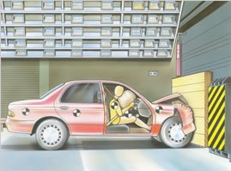
- 2nd Law: When a force acts on an object, the object will start to move, speed up, slow down, or change direction. Force equals mass multiplied by acceleration.
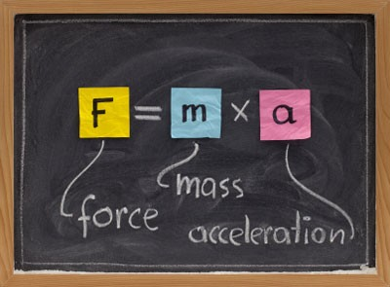
- 3rd Law: If you push or pull an object, it will push or pull you to an equal extent. For every action there is an equal and opposite reaction.
Action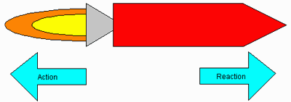Reaction
Laws of Motion Related to Flight
Sir Isaac Newton proposed three laws of motion in 1665. These Laws of Motion help explain how a planes flies.

1. If an object is not moving, it will not start moving by itself. If an object is moving, it will not stop or change direction unless something pushes it.

2. Objects will move farther and faster when they are pushed harder.

3. When an object is pushed in one direction, there is always a resistance of the same size in the opposite direction.

Four Forces of Flight
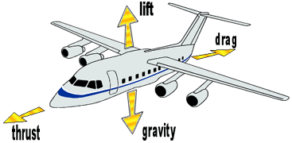

Lift – upward
Drag – backward
Weight/Gravity - downward Thrust - forward

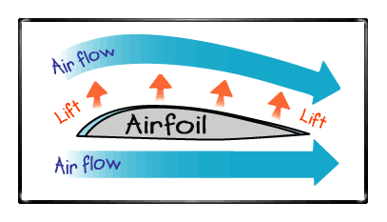
How Wings Lift the Plane

Airplane wings are shaped to make air move faster over the top of the wing (airflow). When the air moves faster, the pressure of the air decreases. So, the pressure on the top of the wing is less than the pressure on the bottom of the wing. The difference in pressure creates a force on the wing that lifts the wing up into the air (airfoil).

NASA for Students

http://www.nasa.gov/audience/forstudents/index.html

Practical Physics—Nuffield Foundation

http://www.nuffieldfoundation.org/practical-physics/newtons-laws-motion

MansfieldCT.org—The 4 Forces of Flight

http://www.mansfieldct.org/Schools/MMS/staff/hand/flight4forcesoverview.htm

Bureau of Labor Statistics--Becoming an Aerospace Engineer

http://www.bls.gov/ooh/architecture-and-engineering/aerospace-engineers.htm

Careers in Aviation and Aerodynamics

http://www.eaa32.org/YoungEagles/Aerospace%20Badge/Aviation_Careers.pdf

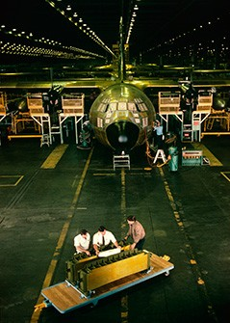
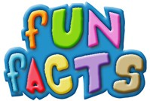

What do Aerospace Engineers do?
Aerospace engineers design aircraft, spacecraft, satellites, and missiles. In addition, they test prototypes to make sure that they function according to design.

Aerospace engineers are employed in industries whose workers design or build aircraft, satellites, systems for national defense, or space exploration.
-U.S. Department of Labor

Activity 1: Newton’s First Law of Motion - Inertia

Newton’s laws of motion describe the relationship between the force acting on a body and the motion of the body.

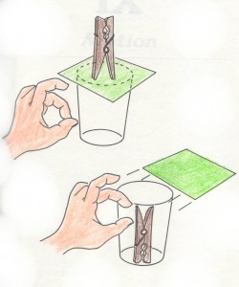

Materials Needed

- 1 heavy drinking glass
- 1 3x5 index card
- 1 clothespin

Newton’s First Law of Motion: This law describes inertia, which means a body will stay at rest (still) or continue at a constant velocity (speed) unless acted upon by an external force.

Example of the inertia of an object at rest: You can remove a paper from beneath a standing clothespin and the pin will fall into the container beneath it.

Activity Directions: Place an index card over the mouth of a heavy drinking glass. Stand a clothespin on top of the card so that it is centered over the glass. Quickly and forcefully thump the card straightforward with your finger. You want only to hit the card and you want the card to move in a horizontal direction.

What’s Happening Here? The clothespin falls straight into the glass about half of the time; the other half of the time it flips over landing upside down in the glass. Your finger applies force to the card, moving it forward. The card quickly moves out from under the clothespin and the pin falls straight down due to the pull of gravity. If you do not hit the card straightforward and/or it is not hit with enough force, the card pulls the bottom of the pin forward and gravity pulls the top of the pin down, causing the pin to flip before it lands.

Activity 2: The Forces of Flight – Drag

Fast Fall,
Slow Fall

Materials Needed

- 1 river rock
- 1-2 sheets of paper
- 1 feather
1) Try this! Drop a stone and a feather from the same height. What happens?

The stone reaches the ground before the feather. That's because of the drag, or resistance of the air. This is a vertical drop:
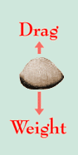
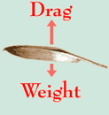
The stone falls quickly because the drag of the air is small (compared to its weight). Drag has a much greater effect on the fall of the feather.

Two astronauts tried a similar experiment (using a hammer) on the Moon, where there is no air.

What do you think they found? Share your ideas with your mentor.

Drag is a force that tries to slow down anything moving through the air. Another name for this force is air resistance.

2) Try this! A sheet of paper falls slowly through the air, like a feather. How can you make a sheet of paper fall more quickly? Investigate ways of making a sheet of paper fall as quickly as possible.

3) Try this! Stones fall quickly through the air. How can you make a stone fall more slowly?
Investigate ways of making a stone fall as slowly as possible.

JOURNAL IT!
From your investigations, write or draw what you have found out about the force called drag. Log your findings in your Science Journal. Share your findings with your mentor!

Activity 3: Paper Helicopters
Part I: Thinking about Weight and Gravity

The pull of the Earth's gravity keeps us on the ground. The Earth is massive (it has a large mass), so the pull of its gravity is strong.

1) Show your mentor: What would it be like to move around, if the Earth's gravity were twice as strong?
The Moon is much smaller than the Earth.

2) Explain to your mentor: What would it be like to walk on the Moon?
The pull of the Earth's gravity makes you heavy. Its force on you is called your weight.

3) Use your imagination: What would it be like if the Earth had no gravity? Share your ideas about the relationship between weight and gravity with your mentor.

Part II: Become a Paper Helicopter Engineer

Construction paper, printer paper, tissue paper, foil, etc.
Scissors, paperclips
Helicopter template

Materials Needed

Activity Directions:
1) Use the Paper Helicopters cutouts on the next page. Cut on solid lines, fold on dotted lines and add two
paper clips to create the prototype paper helicopter shown.

2) Explore the effect of changing some or all of these characteristics of your helicopter.
- Material: Use construction paper, card stock, tissue paper, foil, waxed paper, or…
- Rotor Blades: Change the length, width, number, shape, or…
- Helicopter Body: Change the length, width, shape, or…
- Weighting System: Use more or fewer paperclips, place paper clips in other locations, or use smaller or larger paper clips, use something else as a weight, or…

JOURNAL IT!
What is your definition of a “GOOD” paper helicopter?” Share your best design and explain its features to your mentor. Write about it or draw it in your Science Journal
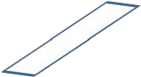
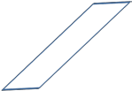
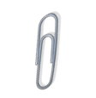
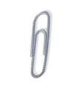
CUT =
FOLD = -- -- -- -- -- -- --

Activity 3: Paper Helicopters

Activity 4: Make and Race Your Own Balloon Rocket

Energy source, friction, drag and Newtonian Principle’s Third Law “to every action there is an equal and opposite reaction.”

Rocket engines are reaction engines. A rocket engine is throwing mass in one direction and benefiting from the reaction that occurs in the other direction as a result. When you blow up a balloon and let it go so that it flies all over the room, you have created a rocket engine. In this case, what are being thrown are the air molecules inside the balloon. Many people believe that air molecules don’t weigh anything, but they do. When molecules are thrown out the nozzle of a balloon, the rest of the balloon reacts in the opposite direction. Blast off!
Materials Needed
- Two chairs, string/fishing line, tissue paper, scissors, glue, measuring tape
- 1 balloon, clothespin, straw, tape, markers
- Light-weight decorations like tinsel & glitter

Activity Directions:

1) Extend a string or fishing line 10 to 15 feet across a room. Tie one end to a chair and tape the other end to another chair. This will provide your Balloon Rocket’s path of trajectory.
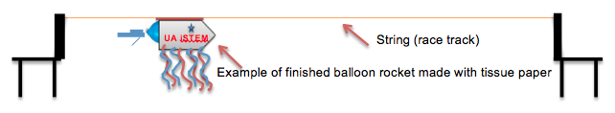

2) Blow up a balloon to a medium to large size, measure around the fattest part (Write down your measurement—you will use this measurement in designing your tissue paper rocket). Twist the end of the balloon three or four times in either direction to ensure that no air will be released before the experiment is ready to begin. You don’t want to tie the end of the balloon in a knot. Instead, you will want to secure this twisted end of the balloon with a clothespin to make certain it does not unravel. When you release the clothespin, this will allow the twist you have made to unravel and allow the air to escape. Consequently, the balloon will take off and rocket along the string as the air is released.

3) Cut two pieces of tissue paper about the same length as the balloon and a little more than half as wide. Cut the front ends to a point and glue them together on the sides and front so it’s like an envelope. Decorate it with few pieces of tinsel or marker designs, and fringe over the twisted end, by making small cuts with your scissors.

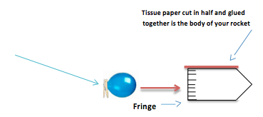
4) Tape the straw to the top of your rocket (the long way).

5) Check to see that your balloon fits into your rocket---if not, let some air out.

6) Put the string/fishing line through the straw (which is now taped to the balloon envelope) and pull the line tight, tying the end of the string to the back of the other chair. Pull the chairs apart to tighten the string. Now your Balloon Rocket is suspended from a tight line or track.
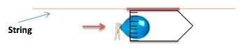
7) When you are ready, remove the clothespin! See how far along the string your rocket blasts! To race someone else, simply set up another string between the two chairs and have two people go at once.

JOURNAL IT!
This experiment demonstrates Newton's Third Law of Motion as every action has a reaction. In this case, by removing the clothespin and allowing the twisted end to unravel, it allows the air to release out of the balloon from one end. The reaction of this is the rocket shooting in the other direction. This experiment also allows you to make inferences and predictions as well as observing and analyzing the results of the experiment.

1. Does the shape of the balloon influence how far (distance) or fast the rocket travels (velocity)?
2. Does the length of the straw affect how far (or fast) the rocket travels?
3. Does the type of string affect the distance rocket travels? (Try fishing line, nylon string, cotton string, etc.)
4. Does the angle of the string affect the velocity of the rocket?

Activity 5: Buoyancy: An Orange Experiment
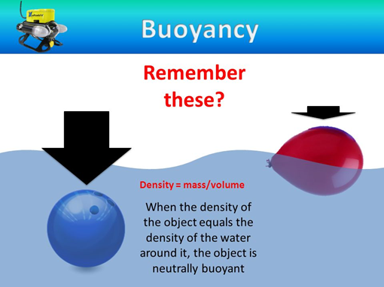
http://images.slideplayer.com/23/6575676/slides/slide_8.jpg

This experiment is a great way to explain the principle of buoyancy.

What you'll need:
- Regular orange
- Peeled orange
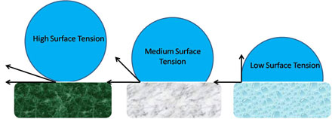
- Deep bowl or pitcher of water
One of these oranges will sink and one will float. Which is which? You might be surprised by the results.
Drop each orange into the water separately. While the orange with the peel is certainly heavier, it will float while the peeled orange sinks. This is because the orange rind retains air. The air bubbles give the orange a lower density than the surrounding water, causing it to float. This principle is called buoyancy.
Surface Tension

Liquids with high surface tension (water) allow items to sit on the surface, while those with low tension would cause the item to break the surface.
Activity 6: Pepper on the Run
Send pepper running with this simple surface tension experiment.

What you'll need:
- Pepper
- Dish soap
- A bowl of water
Pour a generous amount of pepper into the bowl of water. Most of it should float on the top. Put a drop of dish soap on your finger and touch the surface of the water. The pepper will scatter to the edges of the bowl!
This is due to surface tension — a property of water that allows it to resist outside forces. Common dish soap decreases water's surface tension, causing the water in your bowl to spread out and take the pepper with it.

What is happening?
Water has a high surface tension originally, making the pepper float. However, when we introduce soap, it breaks the bonds in water and reduces the surface tension, which then scatters the pepper (it's no longer floating on water).

Flight & Motion Field Trip:

Pima Air and Space Museum
6000 E. Valencia Rd.
Tucson, Arizona 85756
520-574-0462

Contact:
Flight Museum - Mina Stafford MStafford@pimaair.org, 520-618-4800

http://www.pimaair.org/
https://www.facebook.com/PimaAirAndSpace

Admission includes:
- The Main Hangar, 2 WWII hangars, the Space Gallery, 2 docent-led walking tours, restoration viewing, informative exhibits plus 150 more airplanes outdoors!
- The 390th Memorial Museum—a stand-alone WWII military museum located on our grounds
- The Arizona Aviation Hall of Fame

You can also purchase advanced tickets for the exclusive “Boneyard”/AMARG bus tour and much more.

We explored and learned the way rockets take flight! With hands on activities, we built our own experiments that we could take home. Pima Air & Space Museum’s rocket experts lead us through the laws of energy and motion and showed us how they are used in the flight of rockets, the world around us, and much more!

