GPS Science
Arizona Science Standards

3rd-5th grade

1.1PO 1, 1.1.PO 2: Observe, ask questions, and make predictions

1.2.PO 1-3, 1.2.PO 5: Participate in planning and conducting investigations, and recording data.

1.3. PO 4: Organize and analyze data; compare to predictions

1.4.PO 1, 1.4.PO 3: Communicate results of investigations.

6th-8th grade

1.1.PO 1: Formulate predictions, questions, or hypotheses based on observations. Locate appropriate resources.

1.2.PO3-5: Design and conduct controlled investigations.

1.3.PO 3, 1.3.PO 5: Analyze and interpret data to explain correlations and results: formulate new questions.

1.4. PO 5: Communicate results and conclusion of the investigation

2.1.PO1: Identify how diverse people and/or cultures, past and present, have made important contributions to scientific innovations

3.2.PO 4: Science and Technology in Society: Describe a scientific discovery that influences technology. (Grade 6/7)

6.3.PO5: Understand the relationships of the Earth and other objects in the solar system. (Grade 7)

Activity 1: Introduction

Activity 2: GPS Drawing

Activity 3: Constellations!

Field Trip: University of Arizona Planetarium (coincides with Astronomy Module)

Activity 1: Introduction
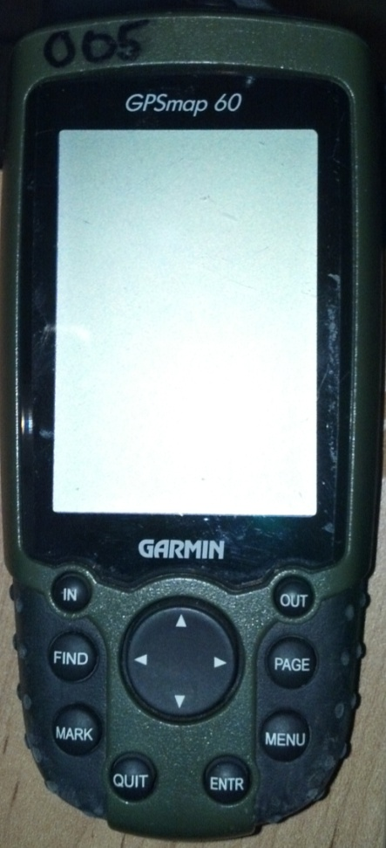
Objectives:
- Learn how to use basic GPS Map 60 Functions

Marking a point:
- Push MARK
- Use directional pad (arrows) to highlight the point name or description. Push ENTR
- Use the Directional pad to input the name or description of the point. Highlight OK on the screen. Push ENTR
- Highlight OK on the bottom right hand corner when done. Push ENTR
- Point has been created!

Finding a Point:
- Push FIND
- Waypoints should be highlighted. Push ENTR
- Use the Directional Pad to click on the next point. Push ENTR
- Read the Description. Highlight Go To and Push ENTR
- Find that point!

Navigating the GPS:
- The IN and OUT buttons are your Zoom.
- PAGE advances you forward one screen
- QUIT is your back button and moves you to the previous screen
- MENU => Tracks => On (ENTR) turns on "drawing"

Useful Terms:
Odometer = Distance traveled
GPS = Global Positioning System
Activity 2: GPS Drawing
Overview: It is important to turn on tracks. Essentially, tracks is “placing your paintbrush on the canvas.” With tracks on, you begin drawing on your canvas. To “lift up your paintbrush,” you must turn tracks off and move to the next area where you want to begin drawing.

Outline of Activity: Be sure you have a satellite lock before starting the activity. Teach the participants how to turn tracking on and off. Remind them about the zoom IN and OUT functions on the map. Make sure they SAVE their work when finished. There is no easy way to “erase” a mistake given the time frame so just tell participants to ignore mistakes.
Turning Tracking On:
- Push MENU
- Push MENU again
- Push ENTR
- Use the arrows to highlight ON. Push ENTR
- Push Page until you get to the map screen
Turning Tracking Off:
- Push MENU
- Push MENU again
- Push ENTR
- Use the arrows to highlight OFF. Push ENTR
- Push PAGE until you get to the map screen
Saving Your Drawing:
- Push MENU
- Push MENU again
- Push ENTR
- Use the arrows to highlight SAVE. Push ENTR
- A save screen turns on. Yes should be automatically highlighted. Push ENTR
- Use the arrows to highlight the NAME data field. Push ENTR
- Type in your name. Highlight OK when finished. Push ENTR
- Scroll down to OK on the bottom right of the screen. Push ENTR

Do not forget to use zoom IN and OUT to see what you are drawing!
Activity 3: Constellations! (Facilitator Instructions)

There are 3 Packets that say group A, B, or C. The objective is to guess the constellation.

Instructions for the activity:
- Ask the Mentor/Mentee pairs which letter they would like. They have to agree on one together. Give them 1 packet.
- Explain to them how to find waypoints using the GPS. (FindWaypointsquit to get out of the keyboardscroll to letter they chose)
- They have to go to the point, mark the point on their sheet of paper in the box labeled "your drawing space"
- Have them read the clue. Then continue to the next clue.

Special Instructions for Lawrence:
- 2 of group C's points are located in an area where the kids are not allowed. Instruct the kids to write the approximation of where the points are on the sheet of paper and read the clues.

Answer key
A = Draco
B = Ursa Major
C = Pleiades

Activity 3: Constellations!

Group A Instructions: Use the GPS to find each constellation point. Place a dot in your drawing area when you find each point! See if you can guess what the constellation is based on the clues and your drawing!
Your Drawing Area!
This Constellation is:

Clues for Group A:
- Roman myth calls constellation Ladon. He was in charge of guarding the golden apples. Hercules shot and killed Ladon with an arrow, making way for Atlas to enter and pluck the golden apples. The goddess Hera was very saddened by the death of Ladon and placed him in sky for eternity.
- Draco has also been identified in early Christianity as the serpent that tempted Eve in the Garden of Eden.
- A Babylonian creation story tells of Tiamat, who turned herself into a dragon but was later defeated and split into two parts. One part became the heavens and the other, the Earth.
- A Chinese tale sees the stars as the dragon that eats the Sun or in an eclipse. During a real eclipse, ancient Chinese would make as much noise as possible, banging on pots and pans to try and scare away the dragon that was eating the Sun or Moon.
- A Norse creation myth tells of a dragon that gnaws at the roots of Ygdrasil, the tree that covers the world.
- The prehistoric Adena people who lived in the Ohio area of the United States created Serpent Mound, which is believed to mirror this constellation. This huge mound is nearly a quarter mile long.
- The Persians have regarded this constellation as a man-eating serpent called Azhdeha.
- This constellation is imagined as an alligator known as Shi-shu-mara. (Hindu)
- This constellation is circumpolar, meaning that it never sets below the horizon and is always visible in the Northern Hemisphere, but cannot be seen in the Southern Hemisphere.
- The stars of this constellation are not very bright, but five of them have known planets.
- From early to mid-October, shooting stars known as the Draconids appear to radiate from this constellations head.

Constellation List
Andromeda | Eridanus | Norma | Sagittarius
Aquarius | Fornax | Ophiuchus | Scorpius
Aries | Gemini | Orion | Taurus
Cancer | Hercules | Pegasus | Ursa Major
Capricornus | Indus | Perseus | Virgo
Cassiopeia | Leo | Pleiades | Volans
Draco | Monoceros | Reticulum | Vulpecula

Group B Instructions: Use the GPS to find each constellation point. Place a dot in your drawing area when you find each point! See if you can guess what the constellation is based on the clues and your drawing!
Your Drawing Area!
This Constellation is:

Clues for Group B:
- The big dipper is one part of this larger constellation.
- He is referred to as the Great Fisher (Anishinabe Tribe)
- The Iroquois say that the blood of this animal who was killed by hunters that turns the leaves red in the fall.
- A girl accepts this animal/constellation as her husband. Her younger sister tells the father, who in turn kills the bear. The older sister changes into a bear to get revenge. (Navajo)
- In the pre-Civil War days, escaped slaves sang a song called “Follow the Drinking Gourd,” related to this constellation, which was a code for which direction to follow when escaping to the north.
- At the end of winter, he turns over to his feet and starts out on his long journey to bring the warm weather back to the Earth (Anishinabe Tribe)
- The Big Dipper make up the seven stars which make up the rump and tail of this animal (constellation)
- A line drawn (up/north) through the outside stars in the bowl of the dipper points to the North Star.
- In the spring, three young braves (the three stars of the Big Dipper's handle) discovered the bear and began chasing it. Iroquois Nation
- This constellation guards the western lands from the frozen gods of the north. In the winter, this constellation goes into hibernation, leaving the land ruled by the ice gods. (Zuni)

Constellation List
Andromeda | Eridanus | Norma | Sagittarius
Aquarius | Fornax | Ophiuchus | Scorpius
Aries | Gemini | Orion | Taurus
Cancer | Hercules | Pegasus | Ursa Major
Capricornus | Indus | Perseus | Virgo
Cassiopeia | Leo | Pleiades | Volans
Draco | Monoceros | Reticulum | Vulpecula

Group C Instructions: Use the GPS to find each constellation point. Place a dot in your drawing area when you find each point! See if you can guess what the constellation is based on the clues and your drawing!
Your Drawing Area!
This Constellation is:

Clues for Group C:
- It is among the nearest star clusters to Earth
- The Aztecs build their great pyramid Teotihuacan (in Mexico City) so that the west face of the pyramid faces the setting of this constellation.
- To the Iroquois it is Oot-kwa-tah. The band of headstrong dancing children
- The seven sisters who escaped from a bear (Kiowa Tribe)
- Seven boys who would not do their ceremonial chores. (Cherokee)
- The orphan boys (Blackfoot)
- It is named for the seven daughters of Atlas and Pleione (Greek)
- Although referred to as the "seven sisters," the cluster actually contains some 1,400 stars. You are looking for the nine brightest stars.
- Rocky terrestrial planets, perhaps like Earth, Mars or Venus, appear to be forming around a star in this constellation.

Constellation List
Andromeda | Eridanus | Norma | Sagittarius
Aquarius | Fornax | Ophiuchus | Scorpius
Aries | Gemini | Orion | Taurus
Cancer | Hercules | Pegasus | Ursa Major
Capricornus | Indus | Perseus | Virgo
Cassiopeia | Leo | Pleiades | Volans
Draco | Monoceros | Reticulum | Vulpecula

