Astronomy
Arizona Science Standards

3rd-5th grade

1.1PO 1, 1.1.PO 2: Observe, ask questions, and make predictions

1.2.PO 1-3, 1.2.PO 5: Participate in planning and conducting investigations, and recording data.

1.3. PO 4: Organize and analyze data; compare to predictions

1.4.PO 1, 1.4.PO 3: Communicate results of investigations.

2.2.PO1: Understand how science is a process for generating knowledge.

3.1.PO1: Describe the relationship between science and technology. (grade5)

6.3.PO6: Describe efforts to explore space. (Grade 5)

6th-8th grade

1.1.PO 1: Formulate predictions, questions, or hypotheses based on observations. Locate appropriate resources.

1.2.PO3-5: Design and conduct controlled investigations.

1.3.PO 3, 1.3.PO 5: Analyze and interpret data to explain correlations and results: formulate new questions.

1.4. PO 5: Communicate results and conclusion of the investigation

2.1.PO1: Identify how diverse people and/or cultures, past and present, have made important contributions to scientific innovations

6.3.PO 5: Understand the relationships of the Earth and other objects in the solar system. Identify the major constellations visible (seasonally) from the Northern Hemisphere. (Grade 7)

Introductory Material: Astronomy

- Overview: An Introduction to Astronomy
- Check It Out! The story of Astronomy student,
Dennis Lamenti (Navajo/Zuni)
- Native American Constellation Stories
Ursa Major: Iroquois
Pleides: Cherokee, Hopi, Blackfoot
Draco: Multiple cultural stories
Orion: Tewa
- Explore More (Resources)

Activity 1: Make a Sun Clock

Activity 2: Create Your Own Solar System Mobile

Activity 3: Assemble your own Planisphere

Activity 4: Design Your Favorite Constellation T-Shirt

Field Trip: University of Arizona Planetarium

Overview: An Introduction to Astronomy
Astronomy is the study of SPACE and the changes that take place in and around all objects moving through space. It's more than just Earth and our Solar System. The study of astronomy covers every planet, object, and bit of energy flowing through the universe.

Careers/Jobs Related to Astronomy
- School Science Teacher
- NASA Aerospace Technologist
- Astronomer
- Astrophysicist
- Space Scientist
- Astronaut
- Mission Specialist
- Astronomy or Physics Professor
- Aerospace Technician
- Community Science Educator (Museum, Children’s Museum, Planetarium)
- Head of Public Programming,
- Data Analyst/Research Technician
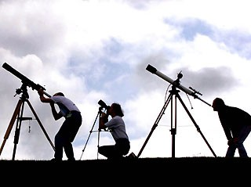
- Science Writer

Education After High School

Associate’s Degree in Astronomy: Pima Community College (2 years after high school).
Bachelor’s Degree in Astronomy, University of Arizona, Arizona State University in Phoenix; in Physics and Astronomy, Northern Arizona University in Flagstaff (4-5 years after high school).
Master of Science in Astronomy, University of Arizona; in Earth and Space Exploration, Arizona State University (6-7 years after high school).
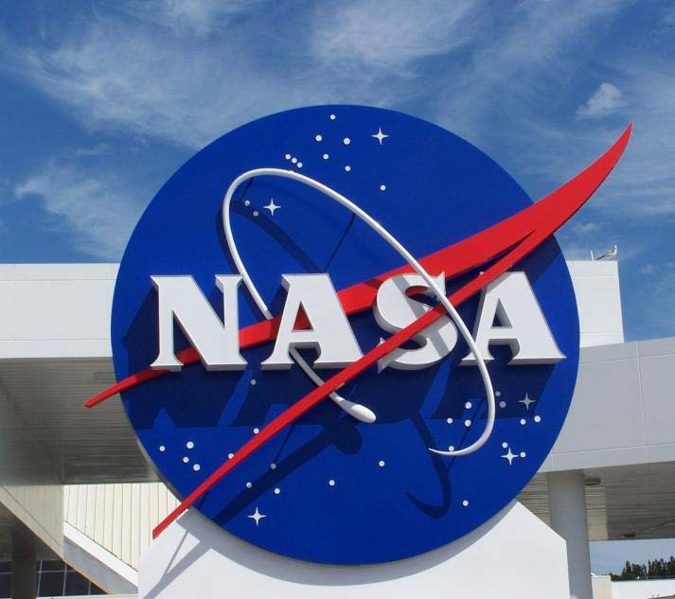
PhD in Astronomy, University of Arizona; in Astronomy and Astrophysics, Arizona State University (8-10 years after high school).

Possible Employers
- Observatories
- Research laboratories
- Schools and universities
- Science museums
- Technology companies
- Planetariums
- National Aeronautics and Space
- Administration (NASA)
- Government agencies
- Media outlet

Check It Out!

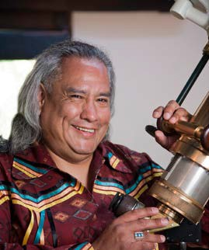
Dennis Lamenti, (Navajo/Zuni) is a graduate student at the University of Indiana. He hopes to bring more Native Americans to the field of astronomy while introducing his culture's astronomic heritage to the world.

Lamenti grew up near Tuba City, Arizona on the Navajo Nation Reservation. He did not go to college immediately after high school. In the 1990s, he started participating in Navajo ceremonies and decided he wanted to better understand his Creator. “And the way to do that for me was to learn more about the creation,” he said.

The physics and mathematics model appealed to Lamenti, so, in 2002, at almost 45 years old, he enrolled at San Francisco State University (SFSU) to pursue a bachelor’s degree in physics. He gravitated toward astronomy in his sophomore year when he was accepted into an internship program at Lawrence Berkeley National Laboratory and placed into its astrophysics division. Now 53, Lamenti is enrolled at Indiana University-Illinois, Bloomington, where he has completed his master’s degree and is close to completing his Ph.D. in astronomy.

Read more at http://indiancountrytodaymedianetwork.com/article/the-native-astronomer-46049

Lamenti would like to make himself available to any Native American students interested in astronomy or who need advice getting into college, or just staying in school. Write him an email! dlamenti@astro.indiana.edu

Ursa Major

Iroquois Tribe

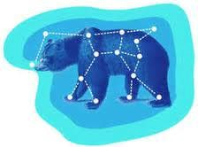
Long ago, the Great Bear wandered freely throughout the sky. His massive paws took him far across the unlimited ceiling of the world. He hunted and fished, finding food in the many rivers of the sky. All throughout the first spring he did this, until his belly was full and happy.

He did not know that three young braves had discovered him feeding that spring. They sought his pelt and meat to feed their families in the long winter that they knew was coming soon.

Without warning, the braves ran out after the bear, trying to catch and kill him. The Great Bear ran, trying to escape from the hunters. All through the long summer he ran, always trying to get away. The braves, however, were very cunning and strong. Eventually they caught up with him. In the first autumn, their arrows pierced the Great Bear and he died.

The blood of the bear spilled out of the sky and tinged all the leaves with red and orange. The trees then dropped all of their leaves in sadness for their friend, the Great Bear.

The Great Bear was reborn the following spring, as is the way of bears, and the braves set out after him again. They do this each year. If you look into the sky and watch, you can see the braves trailing behind the Great Bear as he runs toward the horizon, only to do it again and again with the coming of each spring.

Pleides

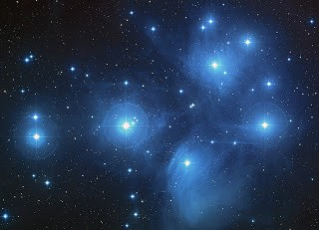
Cherokee Tribe
There were seven boys who would not do their ceremonial chores and only wanted to play. The boys would run around and around the ceremonial ball court in a circle so many times that they eventually rose up into the sky. Only six of the boys made it to the sky; the seventh was caught by his mother and fell to the ground with such force that he sunk into the ground. A pine tree grew over his resting place.

Hopi Tribe
The Hopi built their underground kivas for many uses. The most important of which was a ceremonial meeting place. Access was through a ladder in a small hole in the roof of the kiva, and during certain ceremonies, the night passage of the Pleiades over the center of the opening was a direct signal to begin a certain ceremony. Most of the cultures used the angle of the Pleiades in the night sky as a time telling device.

Blackfoot Tribe

To the Blackfoot tribe, the Pleiades were known as the Orphan Boys. The fatherless boys were rejected by the tribe, but were befriended by a pack of wolves who became their only companions. After a while, they boys were still so saddened by their lives on earth they asked the Great Spirit to let them play together in the sky, and so he set them there as a group of small stars. As a reminder of the tribe’s cruelty to the boys, every night, the tribe had to put up with the howling of the wolves who howled in sadness after their lost friends.

Draco: The Dragon Constellation
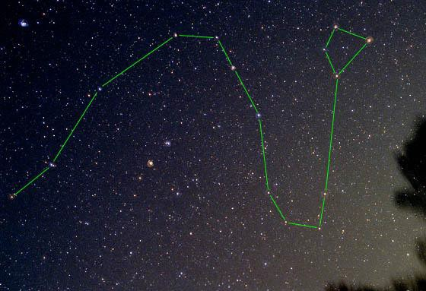
- Ancient sky watchers believed that the Earth revolved around the constellation Draco. Dragons and other similar creatures often played a role in creation myths. In these stories, the Gods would often battle such creatures for control of the Earth. When defeated, the dragons were flung up into the skies.

- Roman myth calls this dragon, Ladon. He guarded the golden apples on a tree in a garden tended by the Hesperides, the daughters of Atlas. Hercules was sent to obtain the apples while under pledge to Eurystheus. He learned from Nereus that he could not pluck the apples himself, but must get help from Atlas. Hercules shot and killed Ladon with an arrow, making way for Atlas to enter and pluck the golden apples. The goddess Hera was greatly distressed by the death of Ladon and placed the dragon in the heavens.

- A Greek legend tells the story of Draco as a horrible dragon that guarded a sacred spring and killed the soldiers of Cadmus (first king of Thebes) who had been sent to gather water. Cadmus then fought the dragon and won. After the dragon died, Athena appeared and told Cadmus to sow the ground with the creature's teeth. The teeth immediately sprang up as a group of armed soldiers who helped Cadmus found Thebes.

- A Babylonian creation story tells of Tiamat, who turned herself into a dragon but was later defeated and split into two parts. One part became the heavens and the other, the Earth.

(Draco: The Dragon Constellation: Continued)

- A Chinese tale sees the stars as the dragon who eats the Sun or Moon (possible represented by the north star Polaris) in an eclipse. During a real eclipse, ancient Chinese would make as much noise as possible, banging on pots and pans to try and scare away the dragon who was eating the Sun or Moon.

- A Norse creation myth tells of a dragon who gnaws at the roots of Ygdrasil, “the tree that covers the world.”

- Around 800 BC, the prehistoric Adena people who lived in the Ohio area of the United States created Serpent Mound which is believed to mirror the constellation Draco. This huge mound is nearly a quarter mile long.

- The Ancient Persians referred to Draco as a man-eating serpent called Azhdeha.

- In early Hindu worship, Draco is given the form of an alligator known as Shi-shu-mara.

From: http://starryskies.com/The_sky/constellations/draco.html

Orion: Long Sash (Tewa Tribe)

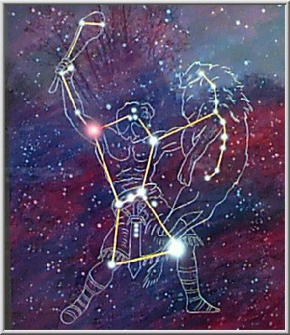
According to the Tewa people (Pueblo Indians from Arizona and New Mexico), the constellation of Orion was their hero Long Sash, named for the long belt he wore. Long Sash was a wise and loved leader. He led his people in a time of great peace and prosperity. But then there came a time of troubles. The crops died. There was sickness and famine. Their enemies were attacking, and times were hard. The people went to Long Sash and said "Lead us away from here! Lead us away from this bad place before we all die!"

Long Sash thought for a moment and replied, "My people, times are bad now, but things may yet improve. If you wish to go on this journey, the way will be long and dangerous. Stop, think, ask yourselves: do you want to take that risk?"

But the people were firm. So Long Sash led them on this dangerous journey. As they traveled, sometimes the people would argue and get into fights. Sometimes they would even start to hit each other. This made Long Sash very sad. He said to his people "STOP! You are hurting each other worse than your enemies have! If you are to come to a place to call your own, there must never be violence among you. So I will build two campfires, and whenever you have a problem with one of your brothers or sisters, go to these two campfires and talk about your problems peacefully.

The stars that form the heads of the Gemini twins are those two campfires. You may notice one of the stars is a little brighter than the other. And that is because the Gemini stars became known as the place of decision making. Long Sash wanted to remind his people that real choices are seldom easy. Sometimes, one path or decision may look brighter or easier than another, but that doesn't always mean it’s the best way to go.

Guided by this wisdom the people continued on their journey until they reached a land so new not even Long Sash had seen it before. This was the middle place, called Earth, and it would be their new home. The people settled down, they had children, and grew older. But Long Sash knew he wasn't going to be with his people forever, so he said "In the sky I will place my head dress as a bright, comforting cluster of stars. So should you ever need to be reminded of my wisdom, look upon these stars and think of me. The constellation we call the Pleiades is really Long Sash's headdress. And even after he died, he still remained in the sky to watch over his people.
Explore More!

1. Build your own space mission!
http://www.jpl.nasa.gov/education/BuildMissionGame.cfm
2. Awesome gallery of space images
http://spaceplace.nasa.gov/gallery-space/en/
3. Who was Neil Armstrong? Learn all about him!
http://www.nasa.gov/audience/forstudents/5-8/features/who-was-neil-armstrong-
58.html
4. NASA Space picture dictionary
http://www.nasa.gov/audience/forstudents/k-4/dictionary/index.html
5. Bill Nye: How do we find planets? (Video)
http://www.youtube.com/watch?v=uC3xDPF8uyI
6. Bill Nye: Planets and Moons (video)
http://www.youtube.com/watch?v=6f6maa9xPDM&playnext=1&list=PL7EAB3907289
5CE73&feature=results_video
7. Astronomy Hangman
http://www.kidsastronomy.com/fun/hangman.htm
8. Hubble Telescope: see what it sees! (Pictures)
http://www.rochesterforkids.com/hubble.htm
9. National Geographic: How our solar system was born (video)
http://www.youtube.com/watch?feature=player_embedded&v=B1AXbpYndGc
10. Lego man in Space! (Video)
http://www.universetoday.com/93070/toronto-teens-launch-lego-man-in-space/
11. Learn about planets and take quizzes!
http://www.planetsforkids.org/
12. Constellation hunt
http://www.kidsastronomy.com/astroskymap/constellation_hunt.htm
13. Keep yourself updated with the latest Astronomy news!
http://www.sciencenewsforkids.org/tag/astronomy/

Activity 1: Make a Sun Clock
History:
Back before 1883, people used solar time. Each community kept its own time, basing that time on the sun's position in the sky. Back then, noon in one town would be four minutes later than noon in a town fifty miles to the east.
In 1883, to regulate time for the sake of railroad schedules, the United States adopted what is called standard time, designating time zones and requiring all communities within a time zone to keep the same time--even though that standard time didn't quite match solar time.
What you will need:
• Pencil
• Compass
• Sun clock diagram (next page)

Directions:
- Go outside with a compass, pencil, and sun clock diagram.
- Place your compass on the ground and turn is so that the arrow and the letter “N” (for North) line up.
- Look at your Sun clock diagram
- Line up your compass with your sun clock diagram, this will allow you to figure out what time it is.

Why do you think it matters where you live in order to figure out what time it is?

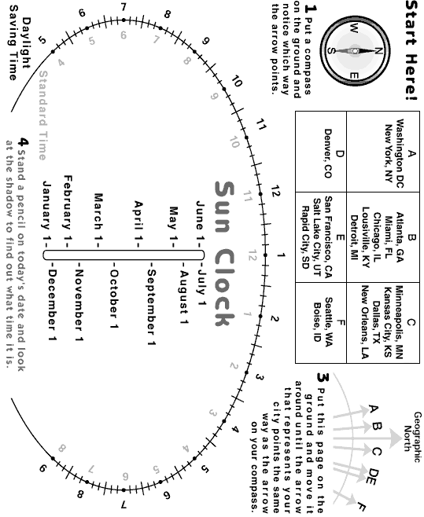

What’s going on?
Why does it matter what city I'm in?
What time it is depends upon where you are on the planet. That's why you use a compass to orient yourself in this activity.
A compass needle (which is attracted to the magnetic field of the earth) points in a direction called magnetic north. That isn't exactly the same as true north, or geographic north, which is the direction of the earth's North Pole. We've set up our Sun Clock so that it uses geographic north as a reference point. If you don't line up the diagram print-out with geographic north, the Sun Clock won't give you the right time of day.
The difference between magnetic north and geographic north is called magnetic declination, and it's different in different locations. When you position the Sun Clock according to the directions on the diagram, you are compensating for the magnetic declination of where you live. After you do this, the "Geographic North" arrow at the top of the diagram will be pointing to geographic north and your Sun clock will work just fine.
How does a shadow tell time?
Shadows change direction, depending upon the time of day. A Sun Clock like this one uses a shadow's position to tell the time.
Why doesn't the time on my Sun Clock exactly match the time on my watch?
The time you get from your Sun Clock is solar time, not standard time. The two aren't exactly the same.
According to solar time, it's noon when the sun reaches its highest point in the sky. But the sun is always moving across the sky--which means that noon where you are is at a slightly different time than noon at a place a few miles to the east or west.
If you are in the middle of your time zone, your Sun Clock will be fairly accurate. If you are at one edge of your time zone, the time on your Sun Clock (solar time) may differ from the time on your watch (standard time) by as much as forty minutes.
Why do I have to put the pencil on different spots for different times of the year?
The position and length of a shadow depends on the time of day--but it also depends on the season of the year. That's because the sun's position at a certain time of day is different in different seasons.

Making a Sun Clock was found on http://www.exploratorium.edu/science_explorer/sunclock.html

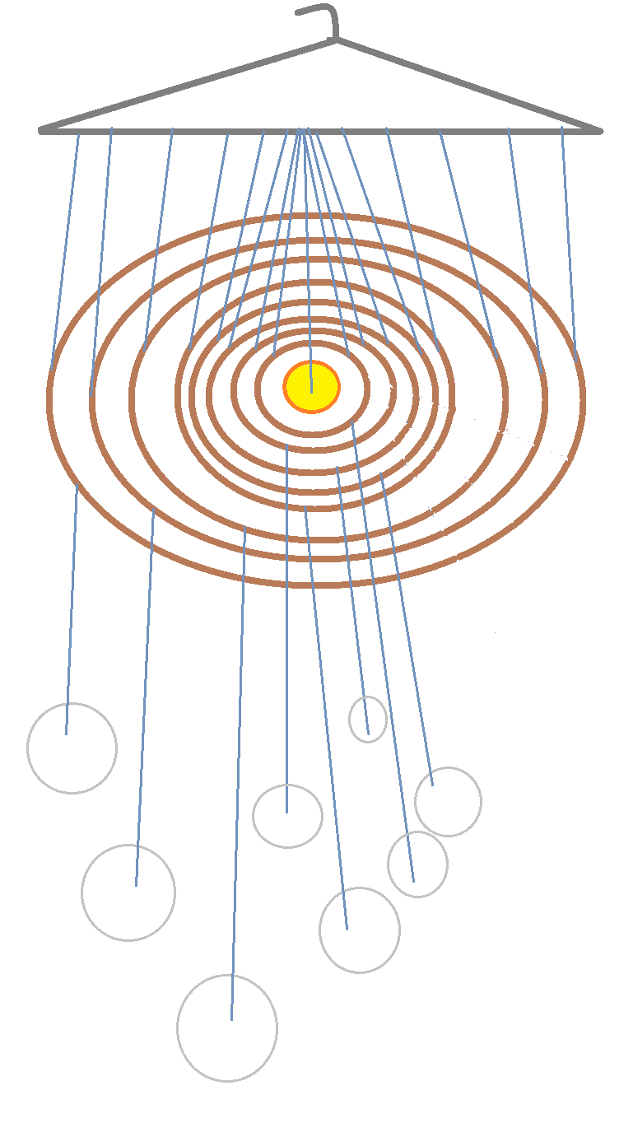
Activity 2: Make your own Solar System Mobile
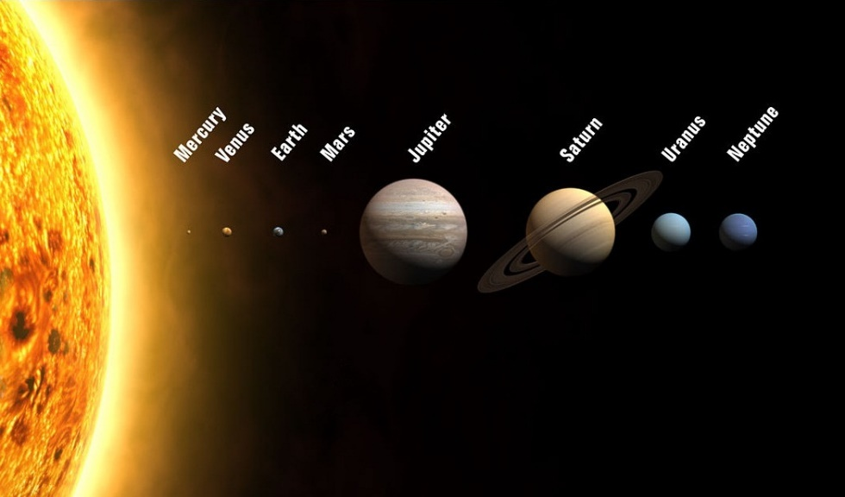

What you will need:

- Clothes hanger
- Cardboard
- Scissors
- Paper/cardstock

- Colored pencils
- Markers
- Metallic Sharpies
- Glitter glue
- String

Activity Instructions

- Draw a dot in the center of a piece of cardboard.
- Use a compass to draw 8 circles (from small to big around the dot. These circles will show the orbits of 8 different planets around the sun.
- Cut out your circles of cardboard.
- With a hole punch or pencil, make a hole where the dot is in the middle of the cardboard. This hole represents where the sun is in the solar system.
- Later we will be hanging our planets from these circles.
- Draw and decorate each planet. Attach a piece of string to each planet with a piece of tape.
- Attached 2 pieces of string to opposite sides of each circle and attached the top of the string to the clothes hanger
- Attach the sun in the middle of the clothes hanger, and each planet to its orbit circle in this order, from closest to the sun to farthest: Mercury (smallest circle), Venus, Earth, Mars, Jupiter, Saturn, Uranus, and Neptune (largest circle).

Facts about the planets:

Mercury:
- Mercury is the planet closest to the Sun. It is not, however, very close, since it is 36 million miles, or 58 million kilometers away from the Sun!
- Like all the other planets Mercury orbits round the Sun, but its orbit of the Sun lasts for only 88 days.
- Mercury’s sunny side has a temperature rising to 400° Celsius or 750° Fahrenheit.
Venus:
- Venus is the brightest planet in the Solar System and can be seen even in daylight if you know where to look.
- Venus has phases like the moon because the orbit of Venus is between the Earth and the Sun. When Venus shows only a crescent, like the crescent moon, she is at her brightest because she is then very close to the Earth.
- Venus is the planet which is closest to the Earth and is a little smaller than the Earth. The circumference of the Earth (the distance right round the middle of the Earth at the equator) is 12,760 kilometers, or 7926 miles. The circumference of Venus is 12,103 kilometers, or 7520 miles.
Earth:
- It is the only planet that has an atmosphere containing 21 percent oxygen.
- It is the only planet that has liquid water on its surface.
- The Earth is the only inner planet (Mercury, Venus, Earth and Mars) to have one large satellite, the Moon. Mars has two very tiny moons. Mercury and Venus have none.
Mars:
- Mars has both North and South polar ice caps, much like Earth. Also like Earth, both ice caps are made mostly of frozen water. With so much water frozen in the ice caps of Mars, some scientists think that life could have once existed there.
- Mars is not much farther from the Sun than Earth. As a result, a typical year on Mars is 1 year and 320 days.
- Mars has seasons like Earth too. These seasons are much longer than Earth seasons because Mars is so much farther from the sun. And don’t get your swim suits out just yet – the average high during a Martian summer day is 23 degrees F (-5 degrees C) – not exactly beach weather.
Jupiter:
- Jupiter is the giant of the Solar System, with a mass more than 300 times the mass of the Earth and is called after the ancient Roman sky-god, Jupiter, known to the Greeks as Zeus.
- Jupiter has a diameter of 88,700 miles, or 142,750 kilometers.
- Jupiter is the fifth planet in order from the Sun and is about 483 million miles, or 777 million kilometers from the Sun.
Saturn:
- The bright globe of Saturn is surrounded by rings which may be composed of ice. Three of these rings are visible from the Earth using a telescope.
- Saturn has at least 18 moons, satellites which orbit round the planet attracted to it by the planet’s gravity.
- Saturn is the second largest planet in the Solar System, after the giant Jupiter. Its mass is 95 times that of the Earth and it has a diameter of 75,098 miles, or 142,750 kilometers.
Uranus:
- Uranus cannot be seen from the Earth without a telescope.
- The seventh planet from the Sun, it was not known in ancient times, unlike the planets from Mercury to Saturn.
- Most of the center of Uranus is a frozen mass of ammonia and methane, which gives it the blue-green color. The atmosphere also contains hydrogen and helium.
Neptune:
- Neptune is the 8th planet from the Sun. Uranus, the 7th planet, was first discovered by means of a telescope in 1781.
- Neptune is one of the four “gas giants”. Like Jupiter, Saturn and Uranus, it is composed only of gas. Neptune is a great ball of hydrogen and helium.
- Like all the other planets in the Solar System, Neptune moves in an orbit round the Sun at the center of the system. It takes Neptune 165 of our Earth years to orbit the Sun.

Here’s a fun way to remember the planets in our solar system!
My
Very
Excellent
Mother
Just
Served
Us
Nachos

Activity 3: Assemble your own Planisphere
http://www.skyandtelescope.com/astronomy-resources/make-a-star-wheel/
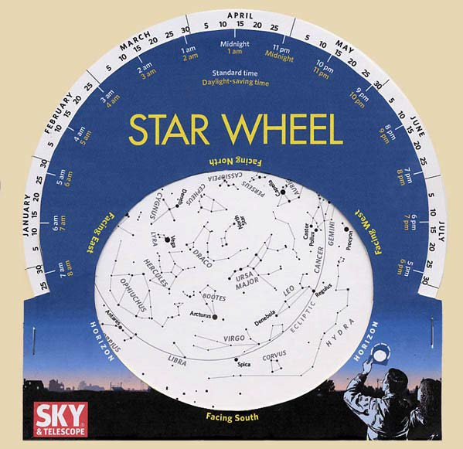
What you will need:
- Circular star map
- Outer sleeve
- Scissors
- Stapler

Activity Directions
- Take the star wheel and cut off the gray corners.
- Take the sleeve and cut out the white oval and the white border in the middle.
- Take the sleeve and fold the white rectangle at the bottom backwards so it is underneath the front.
- Staple it where you see the two tiny white lines.
- Place the circle star wheel inside the sleeve so that the star map can be seen through the oval.
- To use the star wheel, match the date and time at which you want to observe the sky. Turn the star wheel so it matches the cardinal direction (N, S, E, W) you are facing and look at the oval. This oval will show the constellations you should see in the night sky.

TRY IT!
Example: Let’s say it’s tonight at 8:00PM. Face east and turn the wheel so the current date is aligned with 8:00PM. In your journal, write down the names of 3 constellations you would see.

Activity 4: Constellation T-Shirt

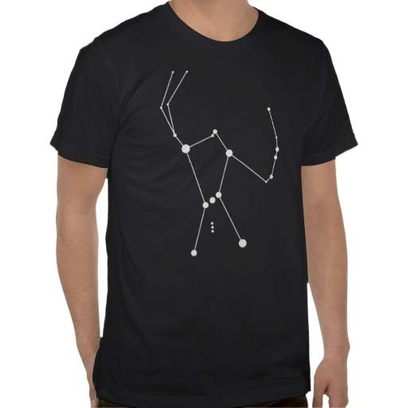
What you will need:
- T-shirt (Black)
- Cardboard piece
- Stencil
- Glow in the dark paint
- Clothespins

Activity Directions:

- Read about the stories that describe the different constellations and find one that is important or meaningful to you. Then choose the stencil that matches that constellation.
- Place your shirt over the cardboard piece so that it is centered in the middle of the shirt.
- Use the clothespins to keep the shirt and cardboard piece in place by pinning the shirt onto the cardboard.
- Take your stencil and using the paint, draw your favorite constellation onto your shirt.
- Wear your shirt in the dark and glow like the stars in the sky! Perfect to wear to the Planetarium!

JOURNAL IT!
- Write down your thoughts on the constellation stencil you picked for your shirt. What made you want to choose your constellation?
- Make up a story about your constellation!
- Ask a family member or elder if they know stories that relate to a constellation.
Astronomy Field Trip:
University of Arizona Flandrau Planetarium
1601 E. University Blvd.
Tucson, AZ 85719
(520) 621-STAR
http://flandrau.org/
https://www.facebook.com/FlandrauScienceCenter

Take a journey through our solar system, learning about the planets and viewing spectacular photos and videos — including images of the sun, moon, Saturn and Mars. Find out what we’ve learned about Mars from the UA-led Phoenix Mission, and ask your questions. Visitors of all ages will enjoy this tour around this galactic neighborhood.
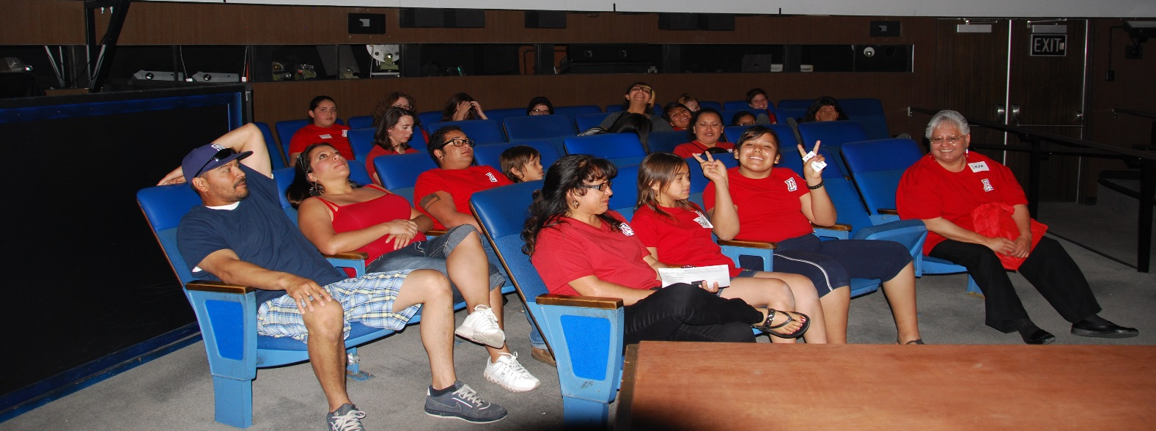

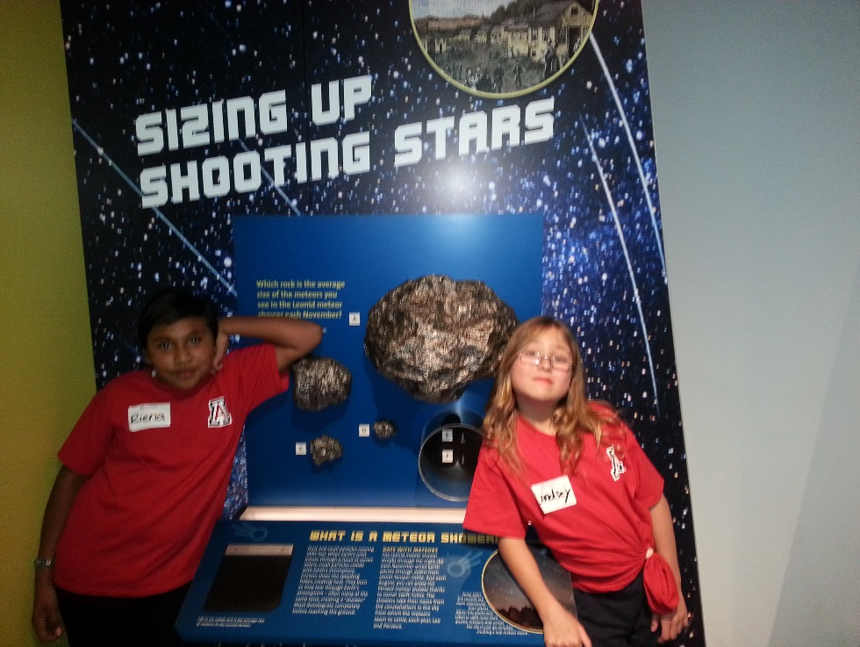
Star Party for iSTEM Friends and Family

We enjoyed a night under the stars on the school campus with the University of Arizona Astronomy Club. The UA Astronomers set up their high-powered telescopes for star, star cluster, constellation, planet and galaxy viewing! UA iSTEM mentees and their mentors shared their iSTEM Program experiences with their families and school community.
