Arizona Science Standards
3rd-5th grade
1.1PO 1, 1.1.PO 2: Observe, ask questions, and make predictions
1.2.PO 1-3, 1.2.PO 5: Participate in planning and conducting investigations, and recording data.
1.3. PO 4: Organize and analyze data; compare to predictions
1.4.PO 1, 1.4.PO 3: Communicate results of investigations.
6th-8th grade
1.1.PO 1: Formulate predictions, questions, or hypotheses based on observations. Locate appropriate resources.
1.2.PO3-5: Design and conduct controlled investigations.
1.3.PO 3, 1.3.PO 5: Analyze and interpret data to explain correlations and results: formulate new questions.
1.4. PO 5: Communicate results and conclusion of the investigation
2.1.PO1: Identify how diverse people and/or cultures, past and present, have made important contributions to scientific innovations
3.2.PO 4: Science and Technology in Society: Describe a scientific discovery that influences technology. (Grade 6/7)
6.3.PO5: Understand the relationships of the Earth and other objects in the solar system. (Grade 7)

Water & Watershed Management

Introductory Materials:

- Overview: Exploring Water & Watersheds

1) Why is Water Important?
2) Where Does Water Come From?
3) What is Hydrology & Watershed Management?
4) Careers & Education in Hydrology and Watershed Management
5) Rio Yaqui Watershed Map
6) An Introduction to the Watershed of the Rio Yaqui
7) Hohokam Irrigation Canals
8) A Story of Water from the A’aninin People, Montana
9) Explore More!

Activity 1: What is a Watershed? Create your own model watershed.
Activity 2: Map Your Watershed (computer based activity)
Activity 3: Explore Erosion—Experiments with water and sand
Activity 4: Capture your rain and grow a Garden.

Field Trip: Sweetwater Wetlands & Urban Water Cycles

Why is Water Important?

Every living thing depends on water. Because we live in the desert, how take care of water and conserve water is even more important! Water issues should be everyone’s concern, but sometimes we think water will always be available to us, where and when we need it. Often we don’t think about water until there is a drought or our water become polluted. That’s why it’s important for all of us to learn about where our water comes from and the things that individuals and communities do that help keep our water clean and available for a long time. All
of us who use water should be good managers of water in our homes, schools and communities. There are also many cool science jobs that relate to water issues.

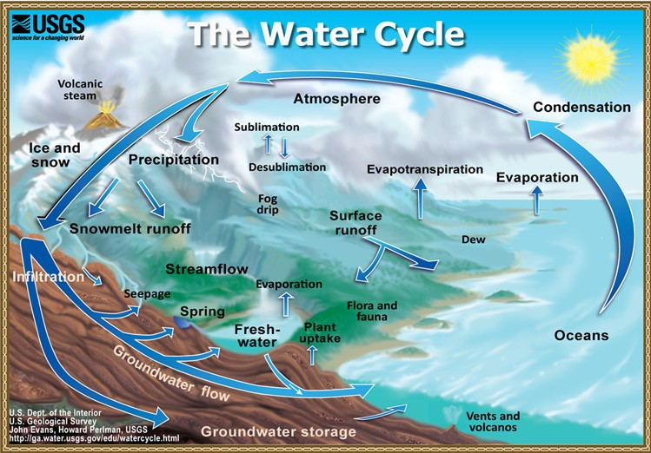

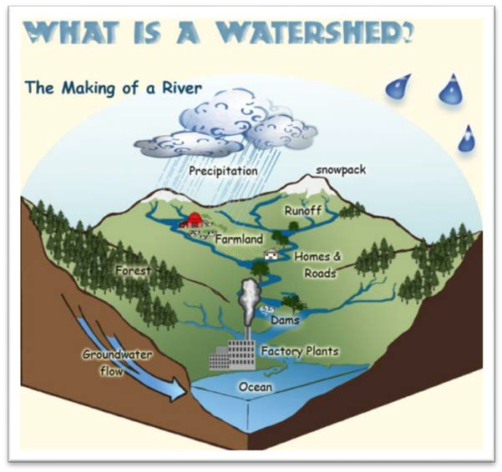What Is A Watershed?

A watershed is the area of land where all of the water that is under it or drains off of it goes into the same place. We can predict where water will flow by measuring slope, geology or land cover.

Where Does Our Water
Come From?

The rain or snowmelt from
Mount Lemmon that flows south into Sabino Canyon belongs to the Sabino Creek watershed. A community’s watershed includes all the land area around it that contributes water to any of its water sources (including rivers, lakes or groundwater aquifers). In Tucson we have groundwater aquifers, which are reservoirs of water underground. Because the water cycle (rain, snow melt) is continual, water is constantly being added to a watershed and thus its water supply. In Tucson, we have long relied on water from our watershed to percolate through the earth to recharge (add to) our groundwater aquifer.

Until 2001, Tucson pumped all of its water from the regional aquifer (sediments below the surface that are saturated with water – like a sponge). When our population was smaller this was enough to meet our cities needs without lowering our aquifer too much. In 2001, Tucson began to mix Colorado River water brought down south via the Central Arizona Project – which is a canal that brings Colorado River water from northern Arizona to southern Arizona. Mixing this water with groundwater allowed Tucson to add to the water aquifer so we wouldn’t run out.

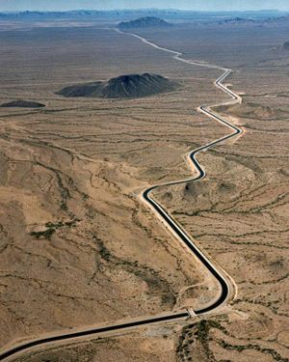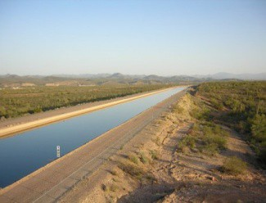

These are photos of canals that carry water from the Colorado River in northern Arizona to central and southern Arizona.

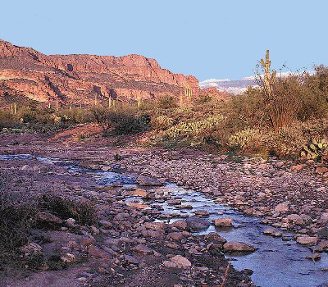What is Hydrology & Watershed
Management?

Hydrology is the science that relates to where water
is located and how it moves across the earth and how humans use and conserve water.

Watershed management is the field that uses scientific practices to protect and manage our water resources. Watershed managers work in a community or in a region to help make plans so that water is distributed to those who need it and to protect the environment. It is an important job and one that is especially important to those of us that live in the desert.

Careers in Watershed Management & Hydrology

er ers
• City or Tribal Land Planner | • GIS Water-Specialist
• Rancher • Computer Programm
• Lawyer • Land/Housing Develop
• Hydrologist • Lumberjack
• Aquatic biologist • Water Treatment Eng
• Hydro-electric Engineer • Park Ranger

ineer

Education in Hydrology & Watershed Management After High School

Associate’s Degree in environmental  technology: | Pima Community College (2 years after  high school)
Bachelor’s Degree IBA/BS) in watershed management, hydrology, urban planning, or sustainability | University of Arizona, Arizona State University, and Northern Arizona State University (4-5 years after high school  *BA/BS. in sustainability available at  ASU
Master’s Degree of Science (MA/MS) in  watershed management, hydrology, geographic information systems or sustainability* | University of Arizona and Arizona State  University (6-7 years after high school).  *Master’s Degree in sustainability available at ASU
PhD (Doctorate) in watershed  management, hydrology, urban planning, and sustainability* | University of Arizona, Arizona State  University (8-10 years after high school)  *PhD. in sustainability available at AS

The traditional homeland of the Yaqui people is along the Rio Yaqui in Sonora Mexico. The river is of great importance to the cultural, spiritual and everyday life of the Yaqui or Yoeme.

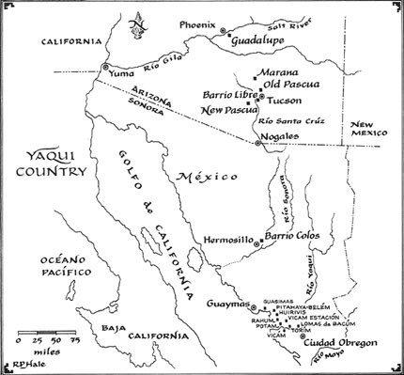

The next section on the Watershed of the Rio Yaqui introduces you to the history and current issues related to the management of the Rio Yaqui watershed and how it affects the people including the Yaqui villages.

Around 600 AD, the Hohokam people began to construct irrigation canals. They excavated trenches up to 12 feet deep by hand, using a digging stick. The trenches funneled Salt River water and spread the water into a
network of smaller canals that brought a steady supply of water to fields. Between 1100 AD and 1450 AD, 500 miles of canals irrigated 110,000 acres. The food produced by this advanced irrigation system is believed to have supported up to 80,000 people—the highest population density in the prehistoric Southwest.

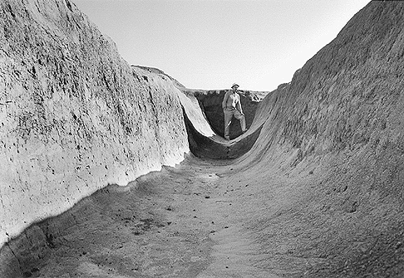

An uncovered Hohokan water canal near Phoenix

Hohokam canals had very advanced features. First, they were wide at the mouth and carefully tapered, getting smaller as secondary branches drew water from the main channel. By shrinking the channel size as the flow decreases, the Hohokam were able to stabilize flow rate. A steady flow rate is key to creating a functional irrigation system. Water that moves too fast carries sand and silt that will eventually block the canal. Water that moves too slowly will not reach its destination. Also, canals covered miles of territory on a relatively even grade, avoiding hills and valleys that could affect flow rate.

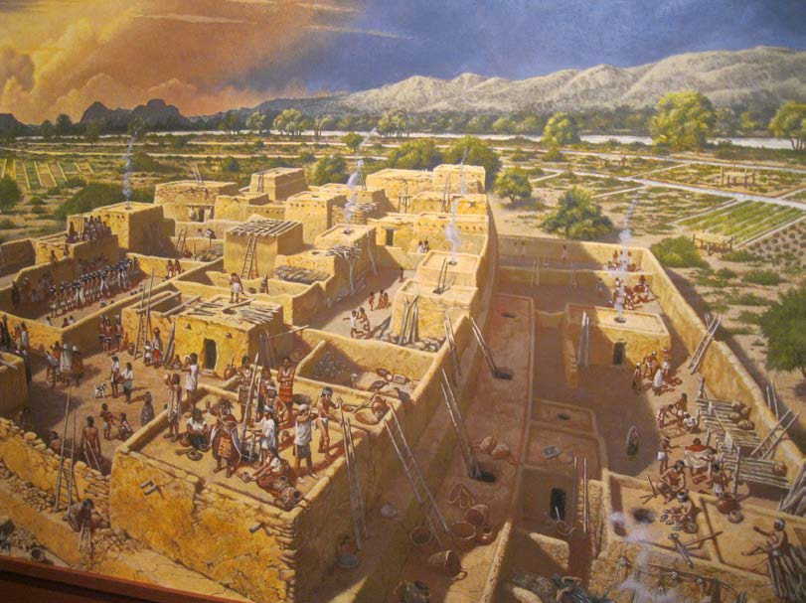

This diagram shows the canal system that supported agriculture in a Hohokam settlement. Anasazi
Heritage Center Pieces of the Puzzle – Hohokam Exhibit displaying new ideas on the Hohokam Culture.

Hohokam canals are responsible for the settlement of Phoenix. Around
1860, there was a gold rush in central Arizona. An early miner, Jack
Swilling, noticed the abandoned Hohokam canals and got an idea. He

started an Irrigating and Canal Company in 1867, intending to use the canals to harvest water from the Salt River to irrigate crops to sell to miners. Soon after, a small settlement called “Phoenix” began to grow.

The most extensive Hohokam canal ruins are located throughout the Salt River Pima - Maricopa Indian Community. Aerial photographs of farmlands show widespread traces of these distribution systems

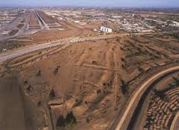

.Archeology Southwest-The Hohokam Archaeology of the Phoenix Basin. Retrievd from:
http://www.archaeologysouthwest.org/pdf/arch-sw-v21-no4.pdf

Sources

Arizona Experience-Hohokam Canals: Prehistoric Engineering. Retrieved from:
http://arizonaexperience.org/remember/hohokam-canals-prehistoric-engineering

Anasazi Heritage Center, Dolores, Colorado: Pieces of the Puzzle – Hohokam Exhibit displaying new ideas on the Hohokam Culture.

Creation Story Related to Water
Tribe: A’aninin People
Region: Montana

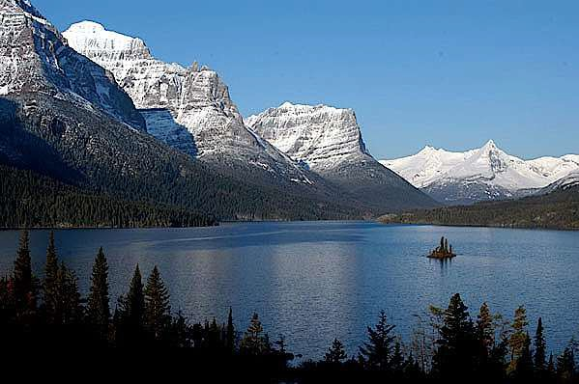

The people before the present people were wild and did not know how to do anything. Because the Creator did not like the way they lived, he thought, "I will make a new world." He had the chief pipe. He went outdoors, hung the pipe on three sticks, and picked up four buffalo chips.
He put one under each of the three sticks supporting the pipe, and took the fourth chip for his own seat.

The Creator said to himself, "I will sing three times and shout three times. Then I will kick the earth. There will be heavy rain, and soon, water will cover the earth.”

So, he sang three times, he shouted three times, and he kicked the earth.

The earth cracked and water came out. Then it rained many days and many nights until water was deep over the earth. Because of the buffalo chips, he and the pipe floated. Then the rain stopped. For days he drifted, floating where the wind and water took him. All the animals and birds had drowned except Crow.

Above the Creator, Crow flew around, crying. When it became tired, it cried, "My father, I am tired and I want to rest."
Three times Crow said these words. After the third time, the Creator replied, "Alight yourself on the pipe and rest."

At last the Creator became tired from sitting in one position and he cried. For a long time he did not know what to do. Then he remembered to unwrap the pipe. It contained all the animals. He took out all those that have a long breath and, thus, are able to dive through water. Large Loon, which he selected first, was not alive, but its body was wrapped up in the pipe. The Creator sang to it and then commanded it to dive and try to bring up some mud. Not half way down, Large Loon lost its breath and turned back. Almost drowned, it reached the place where the Creator sat.

Then the Creator took Small Loon's body from the pipe, unwrapped it, sang, and commanded it to dive for mud. Small Loon nearly reached the bottom before it lost its breath and turned back. It was almost dead when it came back to the surface. Then the Creator took Turtle from the pipe, sang until it became alive, and sent it down after some mud.

Meanwhile, Crow flew about, crying for rest. The Creator paid no attention. After a long time, Turtle came up from the water, nearly dead.
"Did you reach the mud?" asked the Creator.
"Yes," answered Turtle. "I had much of it in my feet and along my sides, but it was washed away before I reached you."

"Come to me." The Creator looked in the cracks along its sides and in its feet. There he found a little earth, which he scraped into his hand. Then he began to sing. Three times he sang, and three times he shouted.
"I will throw this little dust in my hand into the water," he said. "Little by little, let there be enough to make a strip of land large enough for me."

He began to drop it, little by little, opening and closing his hand carefully. When he had finished, there was a small strip of land, big enough for him to sit on. Then the Creator said to Crow, "Come down and rest. I have made a piece of land for myself and for you."

Crow came down and rested, and then flew up again. The Creator took from his pipe two long wing feathers, held one in each hand, and began to sing. Three times he sang, and three times he shouted, "Youh, hou, hou!" Then he spread out his arms, closed his eyes, and said to himself, "Let there be land as far as my eyes can see around me."

When he opened his eyes, the water was hone and there was land as far as he could see. He walked over the earth with his pipe and with Crow. When he became thirsty, he did not know what to do to get water. Then he thought, "I will cry." So, he closed his eyes and cried until his tears, dropping on the ground, formed a large spring in front of him. Soon, a
stream ran from out of the spring. When the Creator stopped crying, a large river was flowing. In this way he made all the streams.

When he became tired of being alone with Crow and his pipe, he decided to make persons and animals. First, he took earth and made it into the shape of a man. Then he took another piece of earth and made it into the shape of a woman. He molded more figures out of earth until he had created many men and women.
When the Creator thought he had enough people, he made animals of all kinds, in pairs. Then he gave names to the tribes of people and names to

all kinds of animals. He sang three times, shouted three times, and kicked the earth. When he had finished, many pairs of living creatures stood before him, persons and animals.

He called the world "Turtle" because Turtle had helped him create it. Then he made bows and arrows, and he taught men how to use them. The pipe, he gave to a tribe called Haa-ninin (A'aninin).

He said to the people, "If you are good, there will be no more water and no more fire. Long before the flood came, the world had been burned. Now this is the third life."

Then he showed people the rainbow and said, "This rainbow is the sign
that the earth will not be covered with water again. Whenever you have had rain, you will see the rainbow. It will mean that the rain has gone. There will be another world after this one."

He told the people to go off in pairs and to find homes for themselves. That is why human beings are scattered.

Explore More!
Arizona Project WET
http://arizonawet.arizona.edu/

Water: Use it Wisely
http://wateruseitwisely.com/kids/

Enivornmental Protection Agency Water, Games and Activities
http://water.epa.gov/learn/kids/drinkingwater/gamesandactivies.cfm

Arizona Department of Water Resources , Activities and Resources
http://www.azwater.gov/azdwr/StatewidePlanning/Conservation2/Education/Student_Educati on.htm

History of Water Management in Arizona
http://arizonaexperience.org/remember/history-water-management-arizona

Wonderville, Water Treatement Interactive Game
http://www.wonderville.ca/asset/water-treatment

The Water Project, Resources for Students and Teachers
http://thewaterproject.org/resources/

Archeology Southwest-The Hohokam Archaeology of the Phoenix Basin:
http://www.archaeologysouthwest.org/pdf/arch-sw-v21-no4.pdf

Kidsgeo.com Hydrology
http://www.kidsgeo.com/geography-for-kids/0158-the-hydrologic-cycle.php

Water Rights: Impacts on Disenfranchised Communities: A Special Report from the Unrepresented Nations and People Organization http://www.unpo.org/images/reports/unpospecialreport_waterpolitics_impactsondisenfranchi zedcommunities_april2010.pdf

ACTIVITY 1:
WHAT IS A WATERSHED?

Materials needed

Shallow plastic bin Cinnamon
Foil Sharpie

Recycled cans, bottles, rocks etc. Food coloring
Rain can!-Poke holes in a can with nail and hammer

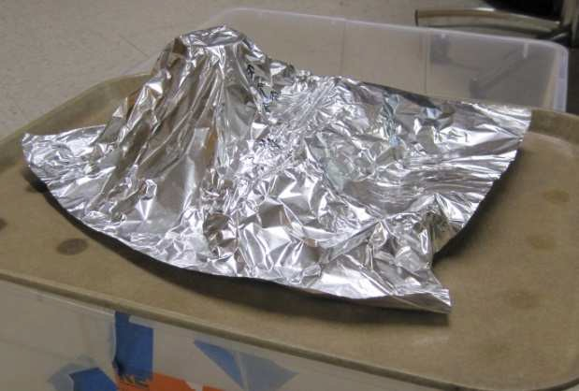
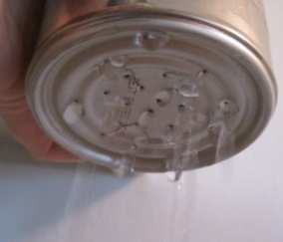

Background: A watershed is the land that channels raindrops into streams and rivers. It incorporates water, topography, vegetation, and human activity. A watershed can be very small (just a local stream) or very large (all the states that feed the Mississippi River that flows to the ocean). We will create our own landscape and make it rain to watch the flow of water!

Water-Activity 1: What is a Watershed?

ACTIVITY 1 INSTRUCTIONS

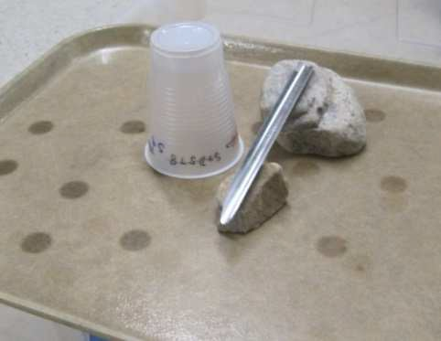1. Place a variety of objects (tall, short, round) under a sheet of foil. Think about when you build a fort with blankets over furniture-- there are high points and valleys. This is will represent a watershed. You can draw dots on the foil to represent a house or draw some trees.

2. Pour some food-colored water (out of a tin can with holes
poked in it) at the highest point on the landscape so you can watch to see where it flows and where it pools.

3. Re-form the landscape, or crinkle up the foil. What happens?

4. Sprinkle a little coco or cinnamon somewhere in the landscape. This represents any water pollutant: E. coli a microorganism that can make you sick found in fecal matter, or heavy metals from mining and roads. Pour water over landscape again and see how the pollutant
moves with the water and how it too pools in rivers and ponds.

How does water move on the landscape, how you are connected by water to people above and below you by the flow of water?

Look at the map of Pima County to find your nearest river.

Identify places in your community and elsewhere that may lead to water pollution. How can you help reduce the pollution that travels across our watersheds?

Water-Activity 1 (Continued): What is a Watershed?

ACTIVITY 2: MAP YOUR WATERSHED!
Materials needed: Computer
Printer

Objective: To find and explore the watershed where your school is located using an internet mapping tool.

Background: Last time we learned that a watershed is an area of land that channels raindrops into bodies of water. We created our watershed, but how do we find the area of our real watershed. They can be enormous! In the past, hydrologists mapped the watershed with paper and rulers, but now we have online tools that anyone can use to learn about their watershed. These detailed maps were created by satellites scanning the surface. People who specialize in GIS use these images and mathematical relations to identify the watershed area, the flow of water, and determine the relationships between the uses of the land, the population and the flow of the water. The map can tell them which areas flood and advice builders, farmers, governments and others about how certain activities might impact the water flow for example: cause flooding. We won’t get that detailed, but we can find our watershed and trace where one drop of water in your schoolyard will travel.

Water-Activity 2: Map Your Watershed

ACTIVITY 2 INSTRUCTIONS

1. Go to http://viewer.nationalmap.gov/viewer/ where we can find Lawrence (just copy and paste in search bar 12SVA9351054506 or Valencia, 12SVA9451258628.

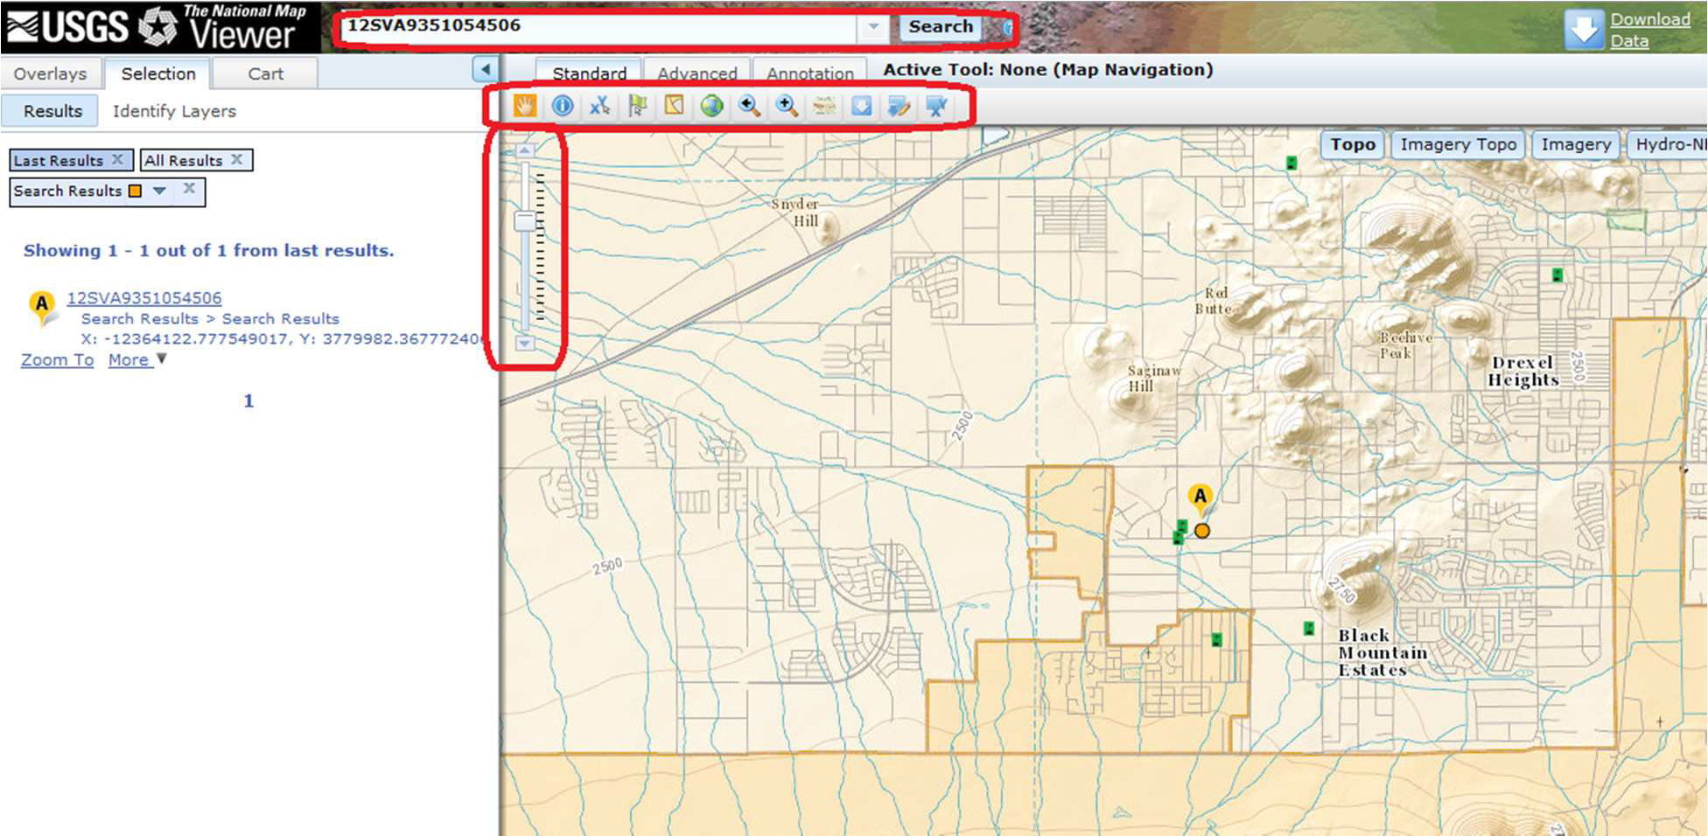

Use a few minutes to zoom in or out to look at the landscape. To zoom in and out, move the
box up and down on the bar that has lines, located on the far left of the map. To move the map, click on the screen and hold down the mouse. Do you recognize the mountain next to the school? Go outside and look at it to make the connection that right now, you are sitting in the building that is on this map and try to get a sense of the scale. Find your house and trace the
road you take to school.

Water-Activity 2 Continued: Map Your Watershed

2. Apply the Hydro-NHD layer to see the watersheds (defined with hydrologic unit codes (HUC)
codes). You might need to zoom out to see this. What is the HUC code for the watershed you are within?

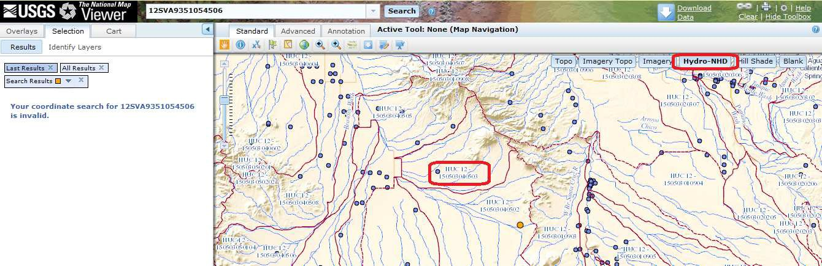

Water-Activity 2 (Continued): Map Your Watershed

3. Click the button to the right of the + magnifying glass for point elevations. The point elevation button tells you how far above sea level the point is that you are clicking on! Find the elevation of the school then click points on the river above and below the school. Find the direction of water flow by decreasing elevations because water always flows downhill.

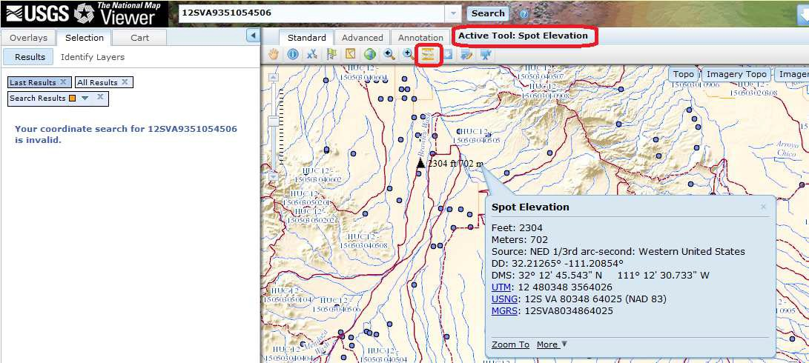

4. Zoom out until you can see the borders of your watershed. What is the name of the main wash, or river, that the water flows to when it comes from your school? Did you find Brawley Wash? Zoom out even more; what river does Brawley Wash empty into? Use the elevation tool to figure this out, water flows downhill. Did you find the Santa Cruz River?

Water-Activity 2 (Continued): Map Your Watershed

5. Measure how far water travels to meet Brawley Wash with the ruler tool in advanced tool bar. The ruler tool tells you the distance from one point to the next when you click on the map.

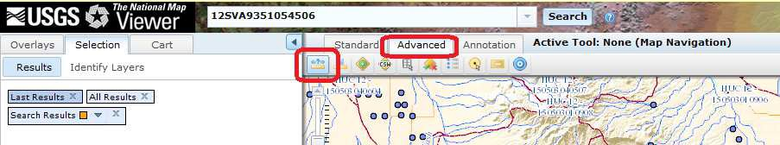
6) Print your watershed and put it in your notebook!

How does water move in your area? Where does it go?
Show a family member your watershed map and tell them what you found out about how water flows in your area.

Water-Activity 2 (Continued): Map Your Watershed

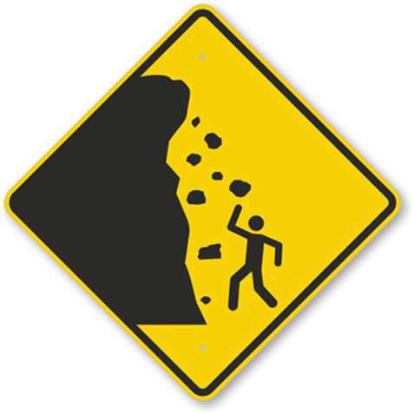ACTIVITY 3: EROSION

Materials needed:

Shallow plastic tub Cloth Blocks/cans Large rocks Rain can! Legos
Popsicle sticks

Objective: Experiment with how water moves sand and how to change that movement. What happens when there is nothing stopping the sand? What happens when you add “trees” or surface roughness (big rocks)? Try creating a cliff and watching the sand collapse when the water hits. Change the angle of the box, what happens? Do you see patterns in the school yard that you see in the box (gullies in the parking lot)? This means that soil from your school is slowly traveling down the streams you mapped in your watershed last week. How can you slow down the rate of your school’s soil erosion?

Background: Erosion is caused by wind or water. Erosion is a natural process that involves the movement of earth from one place to another. There are two forces at work (physics), the mass of the material that because of gravity moves downhill and the friction that holds the soil in place. When you add water, it strengthens the force of gravity because it adds more weight. Also, erosion is linked to the speed (velocity) of wind or water. More erosion occurs when the wind or the water has more energy or velocity. Erosion can cause landslides and other serious problems for humans and for wildlife. For example: After a fire erosion happens very quickly because there are less trees to hold the soil to the land.

Water-Activity 3: Map Your Watershed

ACTIVITY 3 INSTRUCTIONS

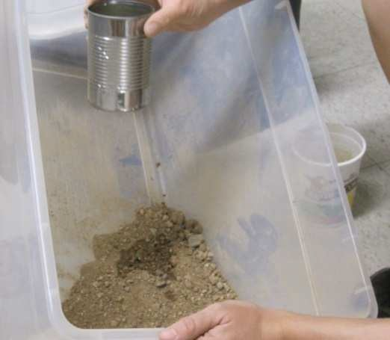1. Place 3-4 scoops of dirt with your hands in the plastic bin. Mix in just enough water to make the dirt a little wet so it sticks in place (1/2 to 1 cup of water). Tilt the bin about 6 inches from the floor and pack the dirt against the bottom with your hands. Fill up your watering can and sprinkle water on the hill you’ve created. What happens to the dirt? Next fill up a can without holes and pour it directly on the dirt. What happens
to the dirt this time?

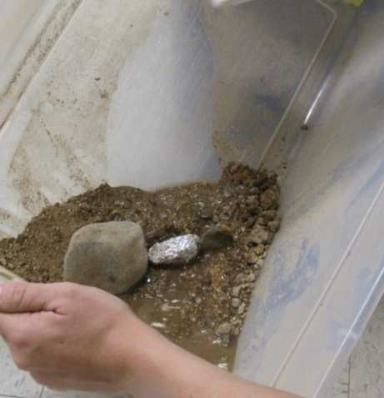2. Place objects in the sand like big rocks, Popsicle sticks (trees), or pieces of cloth. Rain again, what happens? Can you prevent the sand from eroding with trees or surface roughness?

3. Based on the previous steps, make some predictions about what happens when you change the angle of the box or dump all the water at once or just drip the water
out slowly?

Write about how you changed the landscape in your box and what happened to the flow of water when you did this.
What was the least and most effective way to stop the water.
Look up forest fires in Arizona and if there was any flooding after the land burned. If so, why did this happen?

Water-Activity 3 (Continued): Map Your Watershed

ACTIVITY 4: CAPTURE YOUR RAIN AND GROW A GARDEN!

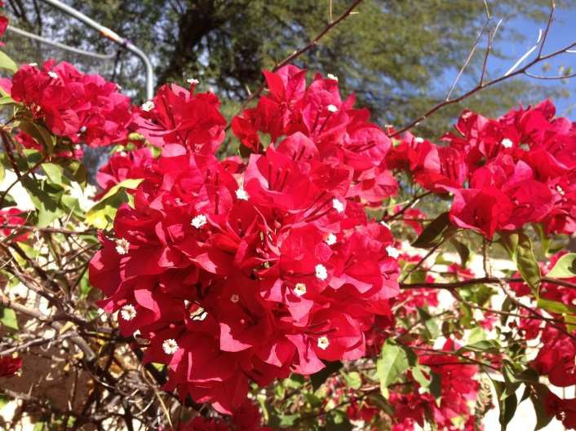Materials needed:

Marbles Google map of school
Level Compostable seed pots
Bucket Local soil

Water Desert wildflowers

Pima County watershed map

Objective: To find possible places to dig a rain garden based on the flow of water moving from the school’s parking lot or roofs. Determine the flow of water with a level or by rolling marbles across the surface to identify erosion. Now that you know how to find where the water will flow, go back to classroom and plant a few seeds to start your own rain garden at home. Learn about plants that are adapted to growing well in the desert. Become familiar with rain gardens and conserving water in the desert.

Background: We live in an urban area where sidewalks and roads move raindrops faster and faster because concrete doesn’t sponge up water like soil. We know from last week that fast moving water creates fast erosion. A good way to prevent erosion and slow down water is to capture it and grow plants! Remember, a watershed manager understands the interactions between water, soil, plants, and people to maximize our benefit and minimize harm to the land and its resources.

Water-Activity 4 (Continued): Capture Your Rain and Grow a Garden

ACTIVITY 4 INSTRUCTIONS

The first part of this activity takes place in the school parking lot. (Take a level and a bucket of water and your map of the school)

1. Determine which direction water is flowing off the parking lot by placing the level on the ground. The bubble inside the level will move outside the black bars when something isn’t flat (level), when a surface tilts or is not level, the farther the bubble moves and the faster the water will flow over a surface. After you use the level, place a marble on the ground and
see if the marble rolls in the direction opposite to the movement of the bubble in the level. If
the ground is almost flat, give your marble a tiny push and see which direction it rolls.

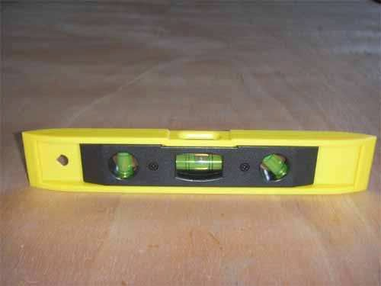

2) Now, look at the edges of the lot to find erosion. Erosion looks like little dry rivers in the
soil. You find these little dry rivers at the edge of the parking lot because when water rushes off the asphalt, it hits the soft dirt so hard it takes little pieces of the dirt with it. Also, look
at the edges of the lot to find erosion. This will tell you where water has flowed in the past.

Water-Activity 4 (Continued): Capture Your Rain and Grow a Garden

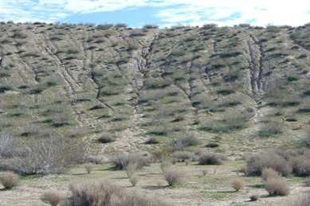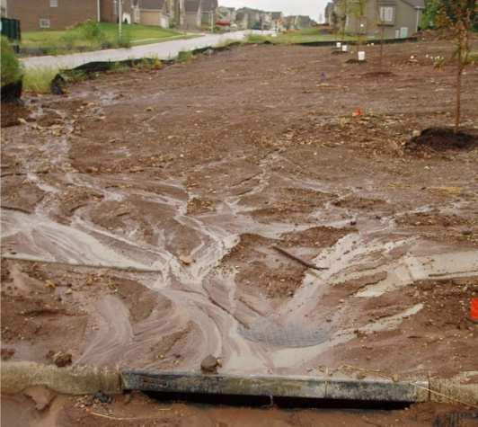

3) Draw arrows to indicate the flow on your map. This is called runoff.

4) Pour some of the water across the surface of the parking lot and compare this to what happens when you pour water on soil. Does it soak in? How fast does the water move on the two surfaces? What happens if you dump it under a plant compared with bare ground?

5) See if you can find drain pipes in the school yard. Can you see signs of erosion?

6) Return to the courtyard to plant a few seeds in a pot. These seeds are for desert flowers that grow well in the desert. You can take this plant home and plant in your yard (pot and all). When you plant your pot, think about what you’ve learned about where water flows naturally because of the shape of the land (terrain). You can capture water that flows off asphalt (sidewalks or streets) to water your plant. If it isn’t the rainy season, be sure to
water your new plant.

Look at the Pima County watershed map and think about how your house and yard channel water. What can you do to capture more water?

Draw a map of your yard and show where you could plant your flower to capture the most amount of water that flows through your yard when it rains.

Water-Activity 4 (Continued): Capture Your Rain and Grow a Garden

Water & Watershed Management Field Trip:

Sweetwater Wetlands Park
2511 W Sweetwater Dr, Tucson, AZ 85745
Phone: (520) 791-4331

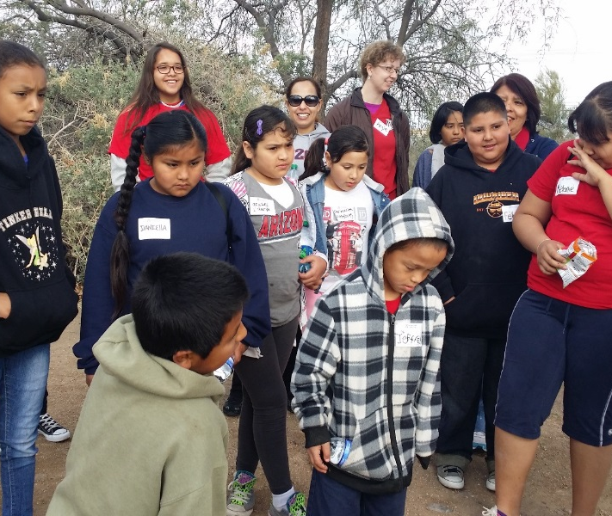

Contact:
Betsy Wilkening
ewilkening1@email.arizona.edu
Tucson Water Education Coordinator,
Arizona Project WET
Water Resources Research Center
350 N. Campbell Ave
Tucson, AZ 85719
520-621-8673

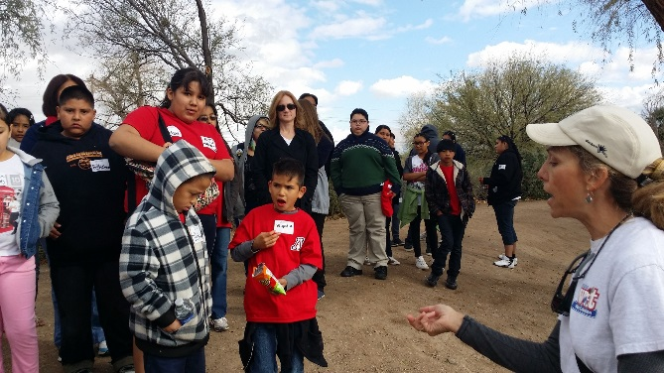

- Introduction to Sweetwater Wetlands and their place in Tucson Water Urban Water Cycle
- Birding Lesson with Jim Gessaman Tucson Audubon Society
- Watershed Lesson with Project WET model
- Water Cycle Lesson

